Zoom: Live Transcription
Live Transcription provides robot transcription services, which enables speech to text transcription in Zoom Meetings and Zoom Webinars. This feature is enabled by the host of the meeting or webinar once it begins. Participants will not see the Live Transcript option unless the host enables it.
This is a two-step process which begins with enabling this function in your Zoom account prior to the meeting. Once you’ve done so, you can turn on live transcription in your meetings at any time.
- Enable Live Transcription for all meetings.
- Turn Live Transcription on during a meeting.

Enable Live Transcription in your zoom account
The Live Transcription function only needs to be enabled in your Zoom account once. After you’ve done so, this option will be available during your meetings permanently.
- Navigate to clarku.zoom.us and select Sign in.
- Sign in with your Clark username and password.
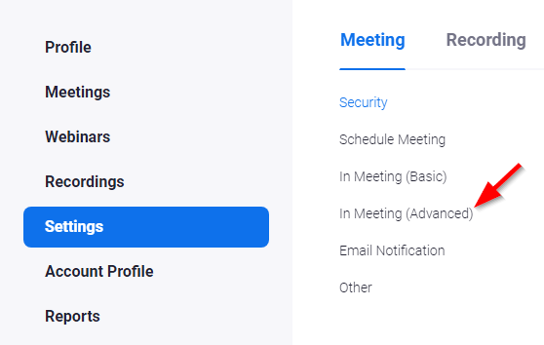
- On the left sidebar, choose Settings, and then, tap In Meeting (Advanced).

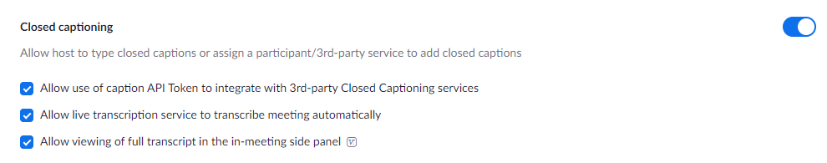
- Locate the Closed captioning heading.
- Ensure that all three checkboxes are selected.

turn on live transcription during your meeting
Note: Live Transcription must be enabled during each meeting in which you intend to use it.
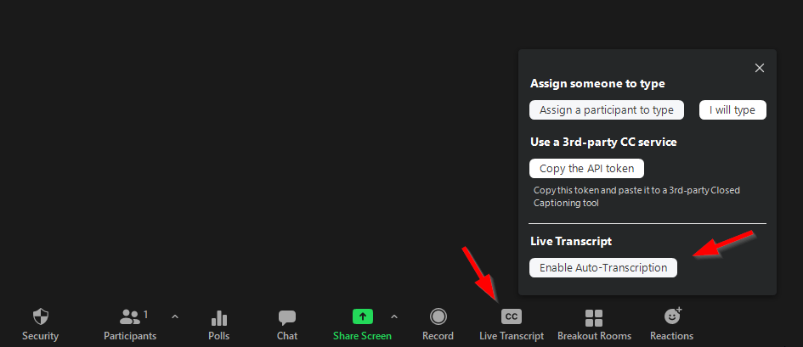
- Start your Zoom meeting.
- At the bottom of the screen, select Live Transcript. If you don’t see it, you might need to resize your window to be wider.
- Tap Enable Auto-Transcription. This button will turn blue, indicating that live transcription has begun.
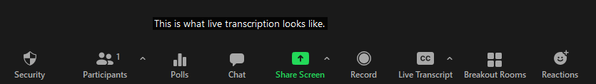
- You will now see live transcription appear along the bottom of the screen.

participants requesting live transcription
A participant now can request that you enable live transcription. They can do so anonymously or by name.
- Participant: At the bottom of the screen, select Live Transcript. If you don’t see it, you might need to resize your window to be wider.
- Participant: A window will appear that will allow you to request Live Transcription.
  - Tap Request if you would like the host to know who is requesting Live Transcription.
  - Check the Ask anonymously selection box and then, tap Request to make an anonymous request.
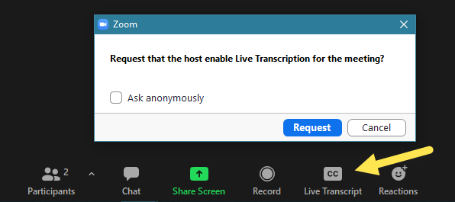

- Host: You will see the following window.
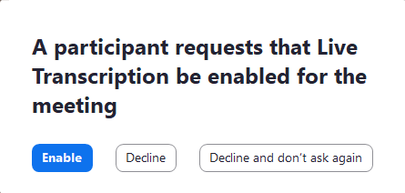
- Host: You can choose to Enable or Decline the request. If you Decline the participant is not notified.

