Accessing Guest WiFi at Clark University
You will need either a social media account (with Facebook, LinkedIn, Google, or Twitter. If you do not have access to a social media account, please contact your event organizer or the ITS Help Desk.

- On your computer or device, go to Settings > WiFi (may also be called Network or Internet) and browse available wireless networks. Select ClarkGuestWifi.
  - See Screenshot 1 below.
- Depending on your device type, a page will either automatically appear, your phone will send a notification to sign into the network, or you may need to open up a web browser and navigate to a non-https website (such as http://nytimes.com).
- Tap the appropriate button to use your Facebook, LinkedIn, Google, or Twitter account to access the Internet.
  - See Screenshot 2 below.
  - Please note that the Google Plus icon will work with any Google account.
- Provide your login credentials to the selected account in order to gain access to the ClarkGuestWifi network.
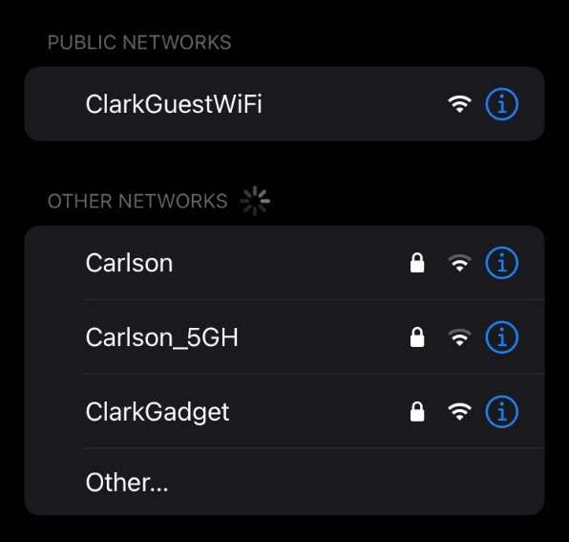
- Confirm that you are connected by checking your WiFi status or browsing to a non-Clark webpage.
Screenshot 1: Select ClarkGuestWiFi from your device settings
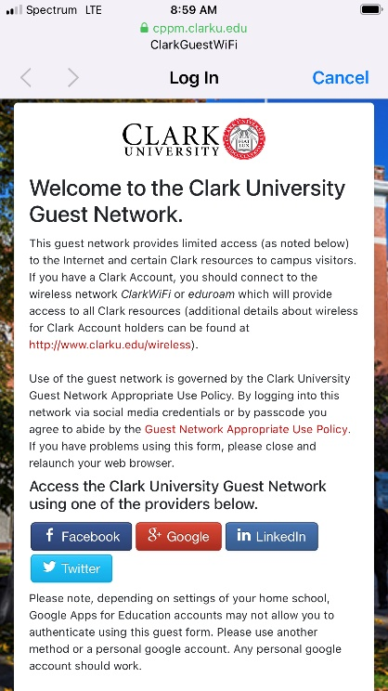
Screenshot 2: Once connected to ClarkGuestWiFi, login using a social media account.

