Cloud Voicemail Instructions
This document covers how to check your Skype for Business voicemail, change your greeting, and change voicemail options.
Voicemail messages left for you on your Skype for Business account are stored in your Exchange mailbox. You can listen to your voicemail messages using your Outlook desktop Application.

Listen to your voicemail in Outlook
Voicemail messages will be delivered to your Exchange mailbox as an audio file along with a text transcript of the message. Using the Outlook desktop application or Outlook Web Access (https://outlook.office.com), you can listen to the audio file through your computer's audio device by double-clicking on it.
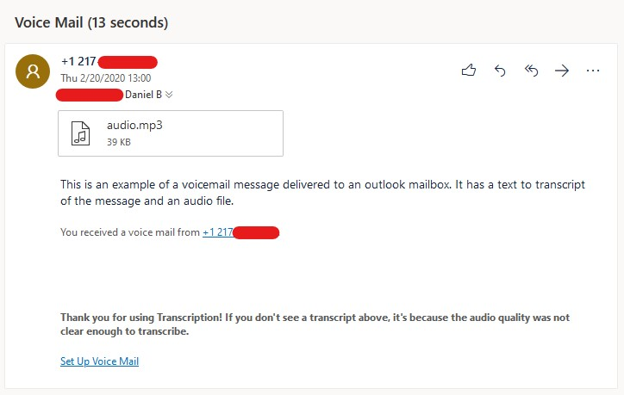

Change your voicemail settings using the Cloud Voicemail Portal
Voicemail settings can be managed using the Microsoft Cloud Voicemail web portal.
From any standard web browser, go to https://aka.ms/vmsettings﻿.
On the Voicemail settings page, you can configure the following settings:
- Change your Call Answering Rules: You can change what options your callers have when they reach the voicemail service; get disconnected, hear your greeting, record a message, choose to be transferred to the number or user you select.

- Change your prompt language: This is the prompt language that is played to callers. For list of supported languages, see Languages for voicemail greetings and messages from Skype for Business.

- Configure your Out of Office greeting: This is the customized greeting message that is played to callers when your status is Out of Office. This option can be activated "Always," when you have an active "Auto Reply" in Outlook, or whenever you have an out-of-office calendar appointment. ﻿
Be sure to click the Save button at the top of the screen after making changes.
