CONNECT YOUR ONEDRIVE TO YOUR VLABS PROFILE
Should you need help or more information, contact the Help Desk via email at helpdesk@clarku.edu or call 508-793-7745.

OVERVIEW
VLabs is a virtualized desktop service that allows faculty and students access to specialist software from their browser regardless of operating system or device specifications.
When using VLabs, while it looks like a normal desktop environment, once your session ends, any files saved to the environment will be deleted. Therefore, you should save all files to your OneDrive account.
These instructions will show you how to connect your OneDrive account to your VLabs profile.
You will only need to connect once, and subsequent sessions will have a shortcut available linking your OneDrive.

INSTRUCTIONS
- Visit www.clarku.edu/vlabs
- Log in with your Clark account
- It may take 1-2 minutes for your VLabs session to begin
- Click on the folder icon in the top left of the VLabs environment
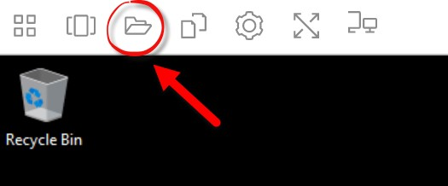
- Click Add Storage in the top right of the pop-up window
- Choose OneDrive
- Choose @clarku.edu
- Click Accept to allow Amazon AppStream access to your OneDrive account
- This will connect your OneDrive account to your VLab profile
- During this first session, you can click on the folder icon to access your OneDrive folders
- During subsequent sessions you will see a shortcut to your OneDrive folder on the desktop

