Use Microsoft Applications on University-Owned Computer: How-To Guide

  - Clark University
Updated Spring 2023
Information Technology Services
Helpdesk@clarku.edu

Windows
- From your computer desktop, click the Windows icon in the bottom left corner of your screen.

- Using your keyboard, type in the name of a Microsoft app (e.g., Word). Once the app appears in the menu, click Open.
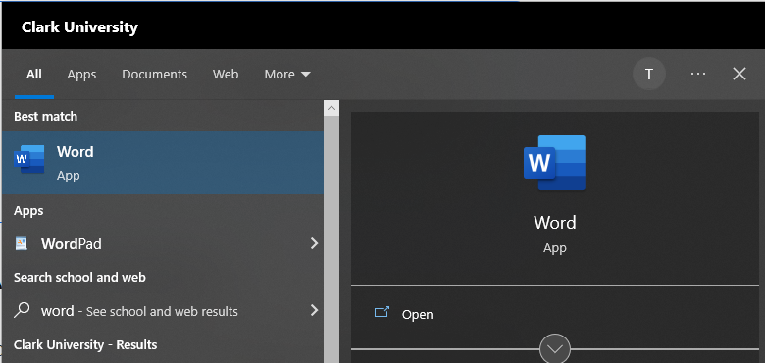
- Repeat Steps 1-2 with any Microsoft applications you’d like to use, such as Excel, PowerPoint, OneNote, etc.
  - Note: Teams may not be pre-installed on your computer. Click here for instructions on installing Teams.
- Optional: pin the tools you use most frequently to the taskbar along the bottom of your screen. Click here to view an instructional video on pinning apps to the taskbar.

Mac
- From your desktop, click the Finder icon located in the dock at the bottom of your screen.
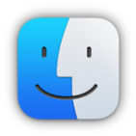
- In the left pane of the window, click on Applications.
- Scroll through the list to locate a Microsoft app (e.g., Word). Double click on the app to open it.
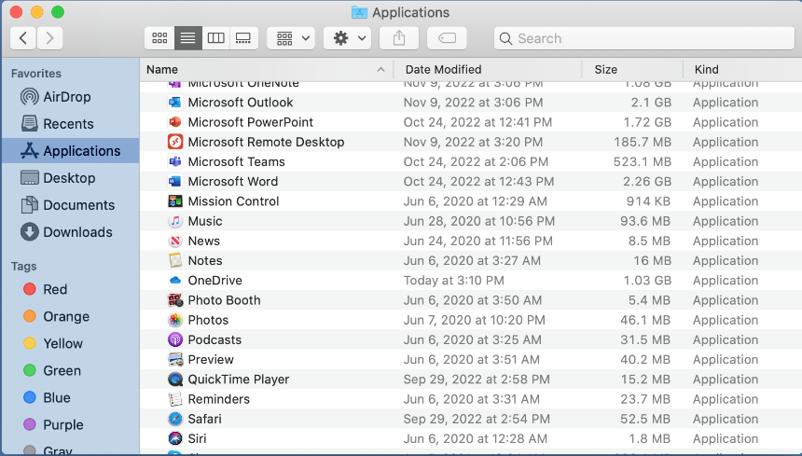
- Repeat Step 3 to open any Microsoft applications you’d like to use, such as Excel, PowerPoint, OneNote, etc.
- Optional: add frequently used applications to the dock at the bottom of your screen. Click here to view an instructional video on keeping apps in the dock.

