Update to Office 2021: How-To Guide

  - Clark University
Updated Spring 2023
Information Technology Services
Helpdesk@clarku.edu

Note on Updating Remotely
If your primary Clark device is a laptop that you use both on campus and at home, you are welcome to update remotely if you wish. Please connect to the VPN prior to updating.
If, when working remotely, you typically remote into a computer that lives on the Clark campus, ITS suggests waiting until you are on campus to start the update process. If this is not feasible, please contact helpdesk@clarku.edu for guidance.
Note on Update’s Effects
General
After the update, your Microsoft applications may have a different format or style. It may take a few days to grow comfortable with this change. If you’d like assistance navigating these changes, please contact techtraining@clarku.edu.
Outlook
Outlook’s format and navigation in particular is impacted by this update. Please view this video for more information on changes within Outlook and instructions on customizing your Outlook ribbon options. You may also contact techtraining@clarku.edu for assistance.
Taskbar
On Windows devices, the taskbar is the black bar shown at the bottom of the screen. Usually, various apps are pinned to this taskbar for quick and easy access, as shown below. The Office 2021 update should remove these pins, which in no way affects your documents or accounts. However, if the pins are still in place after the update, it is necessary to remove them manually, as they will link to expired applications. To remove pins, right click on the icon and select “Unpin from taskbar.” To add the updated apps to the taskbar, please view this video.
Instructions
- Before you begin, close any applications you have running, restart your computer, and after you login, close any applications that automatically open (e.g. Teams, Zoom, etc.)
- From your computer desktop, click the Windows icon in the bottom left corner of your screen.

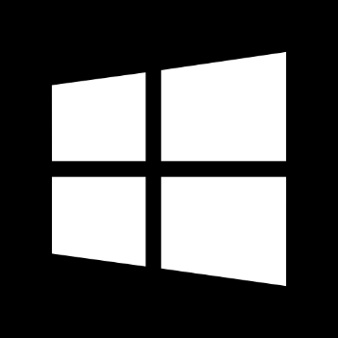

- Using your keyboard, type in “Software Center.” Once the app appears in the menu, click “open.”
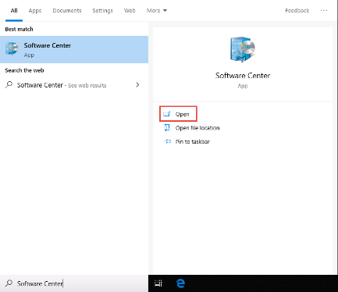

- Next, you’ll see a list of ITS provided university apps in a separate window. From this list, locate and click on “Office Enterprise, Microsoft 2021.”
  - Please note: The older 2019 version of Office Enterprise may also be on this list. Make sure you select the 2021 version.
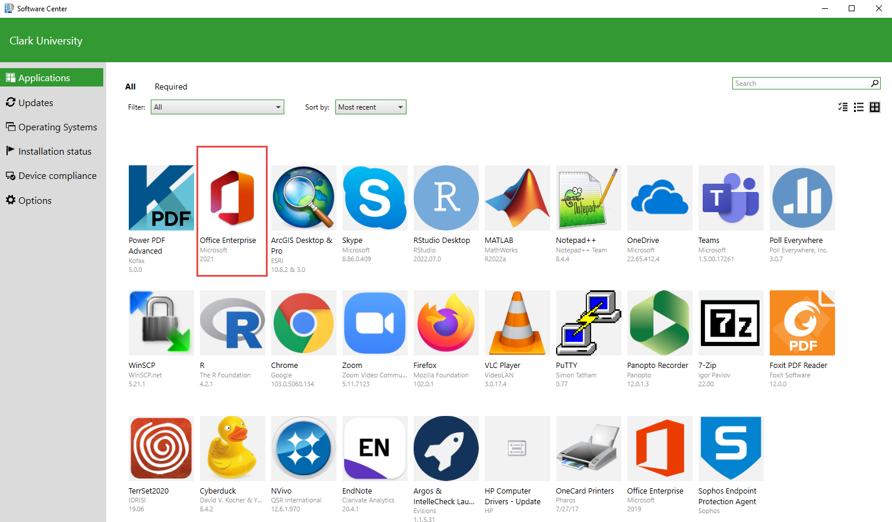
- Click the green “Install” button.
- Wait while the software update installs.

- When the software has installed successfully, the green button will change to “Uninstall” and the status will read as “Installed.”
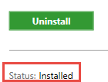
If the installation fails, please contact helpdesk@clarku.edu. Your device or applications may need additional updates.
- When prompted, restart your computer.
  - If you are not prompted to restart your computer, manually restart it by clicking the Windows icon, then the Power icon. From there, select “Restart.”
- Re-open one of your Office apps (e.g., Word), create a blank file, and then go to the File tab. Click “Account” at the bottom of the menu.
- From the Account page, click on “Update Options” and select “Update Now.”
  - Please note: this action only needs to be completed once, in one Microsoft app. The others will update automatically.
