Department Technology Purchases for Employee Home Use: How-To Guide

  - Clark University
Updated February 2023
Information Technology Services
Helpdesk@clarku.edu
techtraining@clarku.edu

Note from ITS
This process applies to technology accessories that are the responsibility of the department which will be used by employees while working from home. Such items include headsets, keyboards, mice, etc., which need to be shipped to the employee’s address rather than the university’s address. This process should be completed by the department’s purchasing person, in conversation with the employees who will be using the accessories. Sales tax applies. This process does not apply to computers, and the department will need to support and address repairs for any technology purchased through this method.
Before You Start
- Confirm you have a department P-Card; purchases can’t be made with POs
- Locate the employee home address(es) to which these items need to be shipped and make sure they are in a place you can easily reference
Purchase Process
- In your internet browser, go to smartbuyplus.clarku.edu/ and log in using your Clark credentials.
- From the SmartBuy Plus dashboard, open the “Catalogs” section.
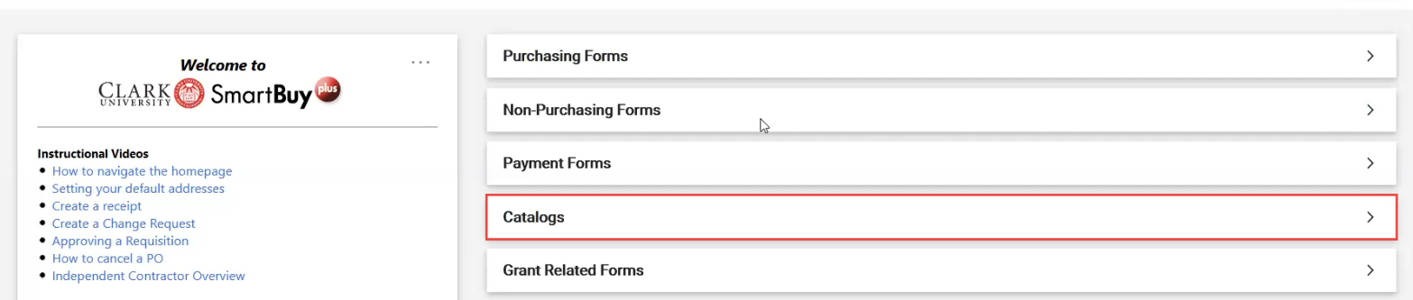
- Click on “B&H” from the list of the university’s approved vendor list.
- Wait for a new window to open.
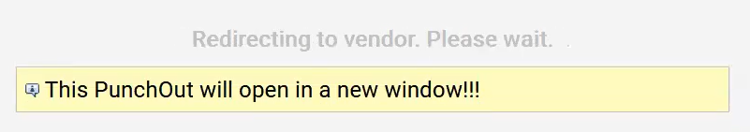

- You will be redirected to B&H’s Clark University purchasing page. From here, search for items requested by departmental employees.
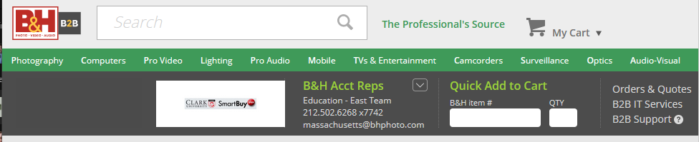
- Once you have located the specific item(s) the department needs to purchase and determined the necessary quantity of each, call B&H’s education account representatives at 212-502-6268, extension 7742.
- The account representatives will place the order over the phone for you using the departmental P-card and ship it directly to employee’s address(es).
  - Tip: Leave the item webpage(s) open on your computer during your call so you can reference the item(s) while speaking to B&H.
- Close the web browser and do not complete the cart to avoid making a requisition for these items
- Confirm with the employee that the item was delivered to their home address successfully.

