Panopto: Recording on Zoom
This document is intended for Clark faculty who wish to upload their Zoom recordings to Panopto. Whether recording an online class session for an absent student or recording a presentation for your professor and classmates, the process is the same. Keep your FERPA obligations in mind when sharing those recordings. Please contact Academic Technology Services for additional assistance.

before you start
- Enable your Moodle course. Tap here for written instructions on how to enable your course.
- Make your course visible. For your students to be able to view your recordings, you will need to make your course visible. Tap here for video instructions on how to make your course visible.
- Ensure that your Panopto block is added to your course, and provision it by tapping the Provision course link in the block. Videos uploaded to this course folder in Panopto will automatically display in the Panopto block for students to access.

recording to the cloud
- Open the Zoom desktop application.
- Sign in with SSO (clarku).
- Start your Zoom meeting.
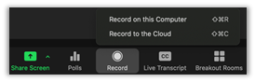
- To record, tap the Record button on the bottom of your screen and select Record to the Cloud.

- Your recording will begin uploading to Panopto after you End your Zoom meeting (End Meeting for All). The uploading process can take a few minutes. You will receive an email at your clarku email address when it has finished uploading to Panopto.
- To view your recording, go to clarku.hosted.panopto.com and sign in with your clarku account.
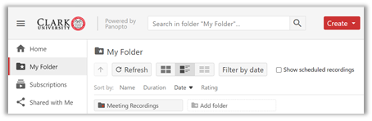
- Once you log in, you will be automatically directed to My Folder, where your previous Panopto uploads are housed. Tap the Meeting Recordings folder.
  - If you don’t have a Meeting Recordings folder, or it’s unexpectedly empty, please contact Academic Technology Services.

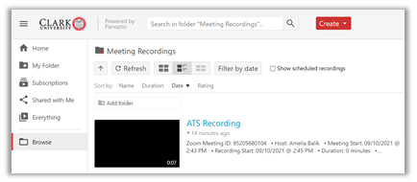
- Your new recording will appear at the top of your saved Zoom recordings in the Meeting Recordings folder.

move your panopto recordings
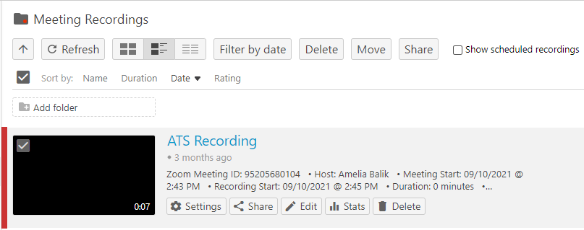
- In your Meeting Recordings folder, select the video that you want to move.
  - Hover over the video.
  - Check the box that appears in the top-left of the video.

- If you wish to move multiple videos at once:
  - Check one video using the instructions in Step 1.
  - An additional box will appear at the top of the screen to select all.
- Tap the Move button at the top of the screen.
  - The Move button only appears once a video has been selected.
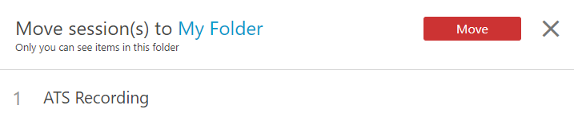
- Select your Course Folder from the drop-down menu.

- Tap the red Move button.

Should you need help or more information, contact the help desk via email at helpdesk@clarku.edu or call 508-793-7745.

