wireless screEn share
This document will provide you with some basic steps on how to use Solstice wireless screen sharing for classroom collaborations. Should you need help or more information contact the help desk via email at helpdesk@clarku.edu or call 508-793-7745.

turning on the screen share
Step | Action
 | From the classroom podium’s control panel, select “SCRN SHARE”. | 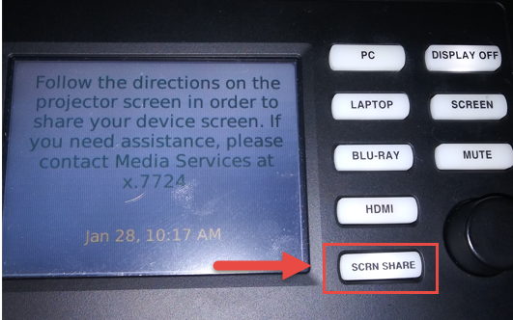
 | The screen share “pod” will now appear on the primary display.  The room identifier will be in the upper left corner.  Instructions for how to connect to the pod will be in the upper right corner.  Collaborators can connect using their mobile device or by going to the URL on the screen and downloading the app. | 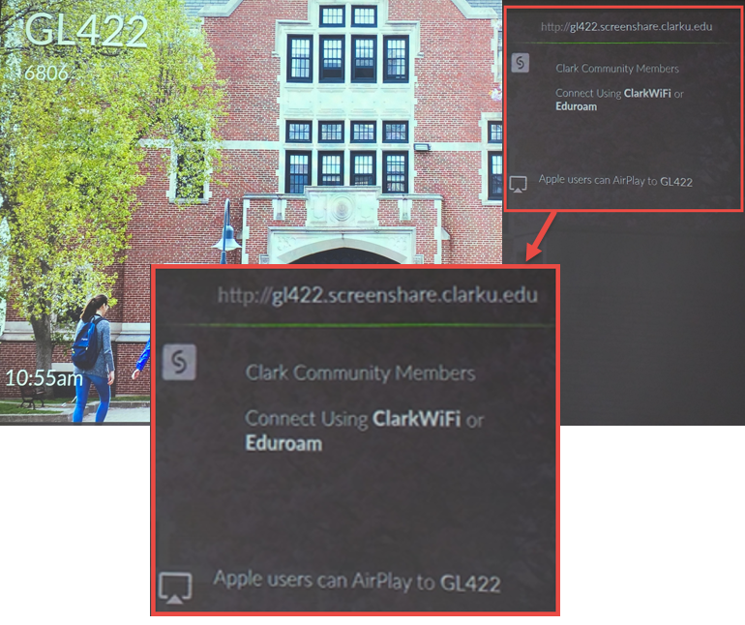

downloading the solstice client to your device
Step | Action
 | PC/Mac - Open a web browser and go to the URL listed in the upper-right corner of the Solstice Pod's welcome screen. The page that loads will include a download link for the Solstice client.  Mobile devices - Open a web browser on your device and go to the URL listed in the upper-right corner of the Solstice Pod's welcome screen; you will be redirected to the appropriate mobile store to install the Solstice app. | 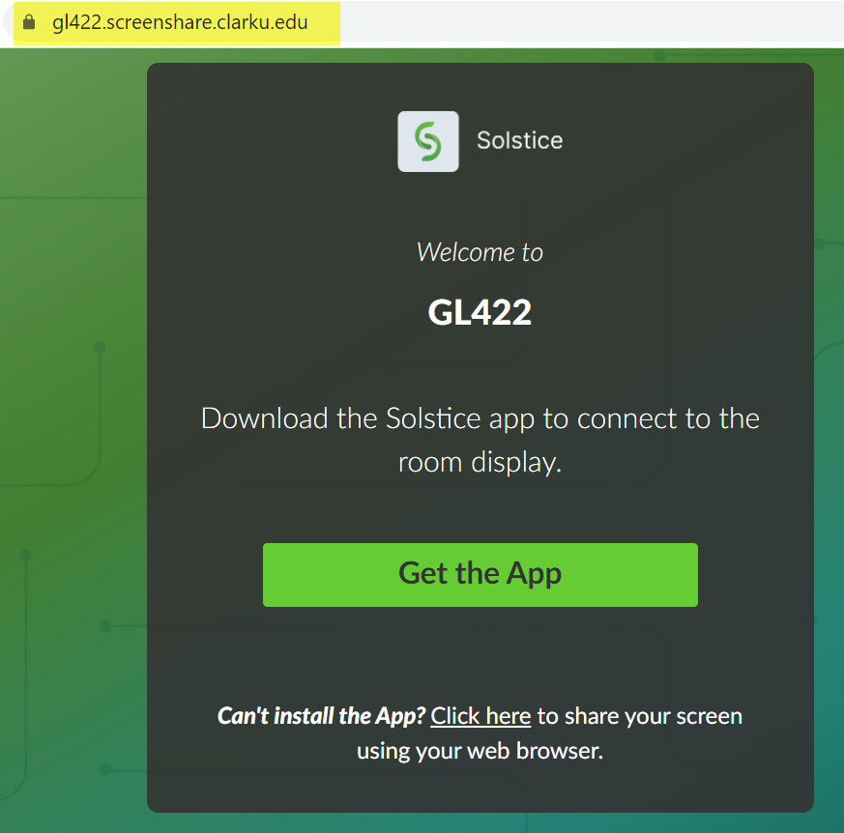

connecting to solstice
Step | Action
 | Open the Solstice client.  On first use, you will be prompted to enter your name. This helps distinguish your content while collaborating with others.  Mac users will be prompted to grant additional permissions in the Security preference pane. | 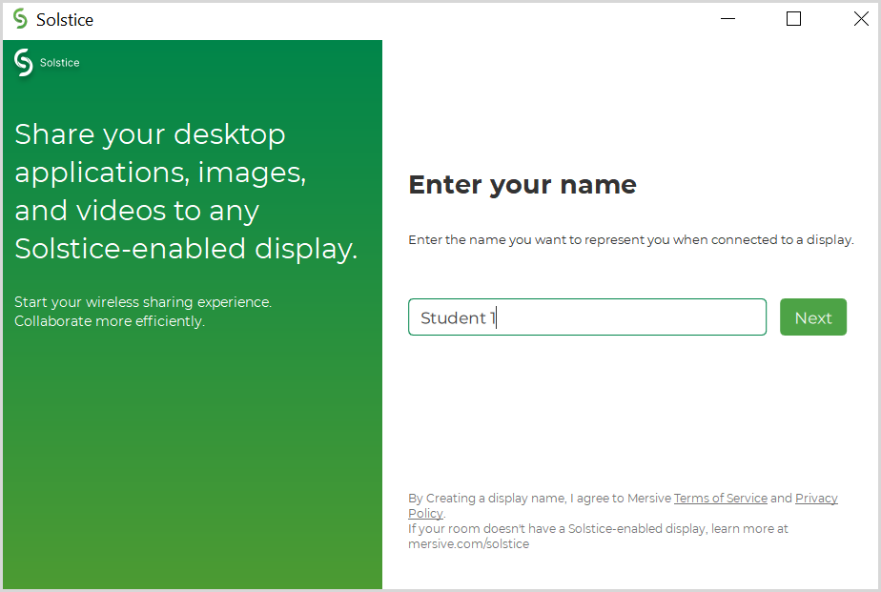
 | The primary classroom display will display a 4-digit code.  If another user is already sharing, this code may be displayed in the bottom left corner of the screen. | 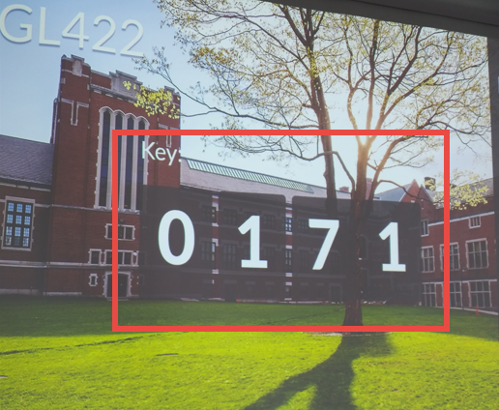
 | Enter the 4-digit code on your device and click Connect. | 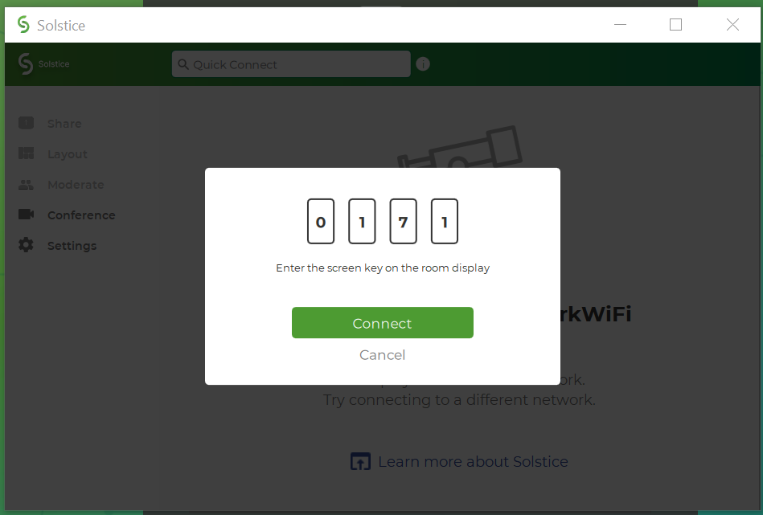
 | Choose a sharing method. You can share your entire desktop, an open application window, or stream a media file directly from your hard drive. Full audio sharing support is provided for sharing Desktop or a Media File.  For iOS users: Mirror your screen under iOS, click Mirror Screen. Follow the instructions to enable Airplay on your device and toggle Mirroring on. | 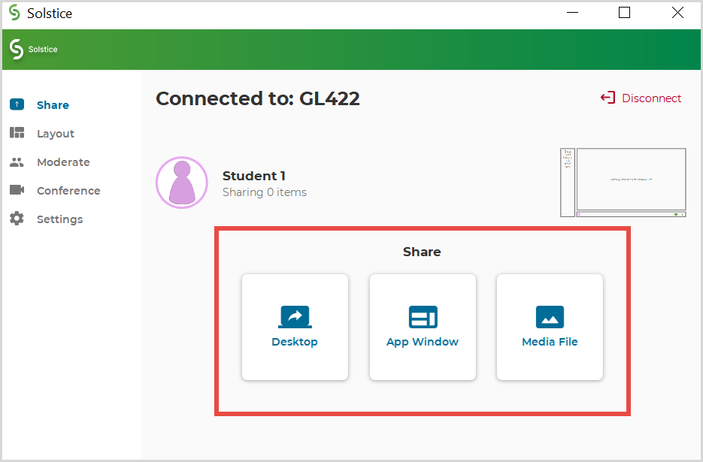
 | You can change what you want to share and stop sharing by clicking on the button at the top of your share screen.

