Clark University – Information Technology Services
Poster Event Request Form

Information Technology Services provides poster printing services for Clark University students and employees who are presenting at on-campus and off-campus events.

Poster events, especially large ones, may require longer printing times. Depending on the size of your event, and in case there are concurrent events, we may need between 1-2 weeks. Once we receive your request, ITS staff will be in touch to schedule your event and help determine an appropriate deadline for submissions.

Send completed form to: posters@clarku.edu with the subject line: Event Request

Event Details

Event Coordinator Name:
Event Coordinator Email:
Title of Poster Event:
Department Sponsoring Event:
Date of Event:
Approximately how many posters do you expect will need to be printed?
Are there sizing and/or paper type requirements for submissions? If so, please indicate what those are in the space below.
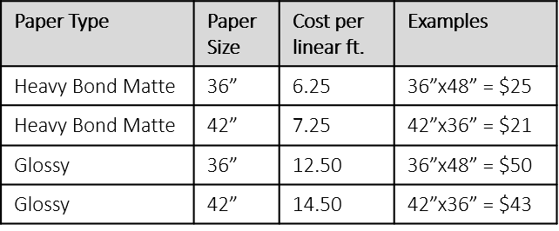

Billing Information
Most events are paid for by an interdepartmental requisition. In this case, students will receive an “event credit” covering all or a portion of their print job and pay out-of-pocket (cash only) for any amount that goes over the event credit.

The day after the event, ITS staff will send a detailed invoice for the total amount as well as information about where to send the interdepartmental requisition.

Will the event be paid for by Interdepartmental Requisition?
If yes, how much will the Event Credit be?
To whom should we send the invoice? (Name and email)

Notes

