Panopto Guide for Students
This document explains how to access the Panopto server, how to upload pre-recorded video files, and how to create a video and publish to Panopto. If you are a ChromeBook user, tap here for instructions on how to record and share with Panopto Express.

How to access Panopto
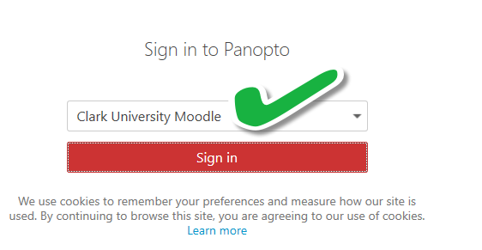
- Go to https://clarku.hosted.panopto.com/.
- Select Clark University Moodle from the dropdown list.
- Tap Sign in.
- Select Clark Login and enter your Clark email address and password.

Where to upload video files
The course name/project determines where to upload your video file. As such, you will look for and upload your video to the folder named CourseName [assignments].

Example of course assignments folder name:
ECON010-02-S22 [assignments]

Example of event assignments folder name:
Academic Spree Day 2022 [assignments]

option 1: Capture & publish with panopto capture
- Log in to Panopto.
- Tap the red Create button at the top of the page, and select Panopto Capture.

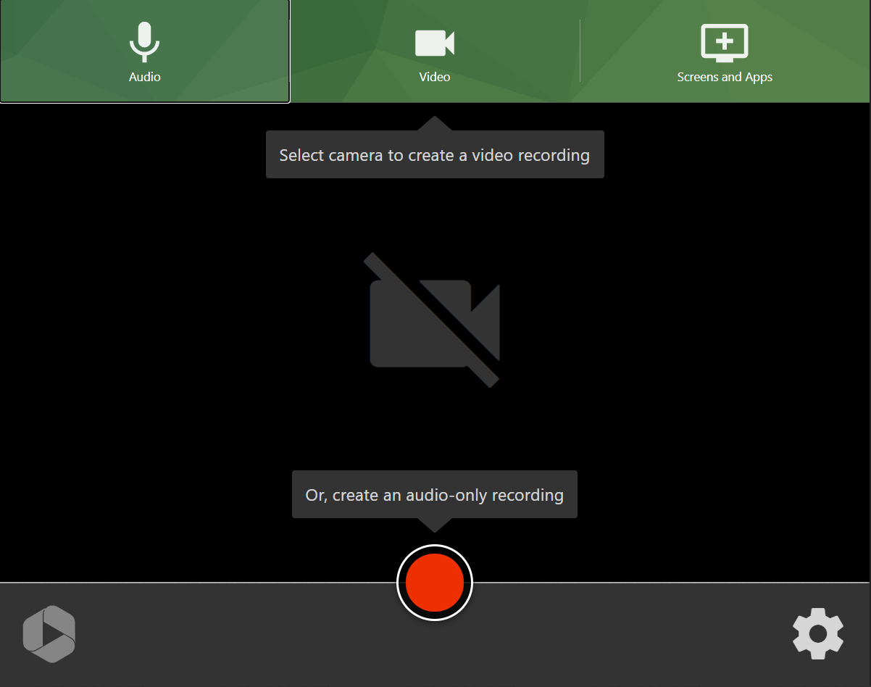
- To enable or disable audio capture, select your audio source by tapping Audio at the top of the screen. To enable or disable video capture, select your video source by tapping Video at the top of the screen. You can utilize both audio and video, or one or the other.

- To begin recording, tap the red circular record button in the bottom center of the screen. Panopto Capture will count down from 5 before it begins recording.

- When you finish recording, you can edit your video’s title, location (ensure you are submitted to the respective CourseName [assignments] folder), and description.
  - You can tap Edit to make edits to your video clip and View to watch it.
  - You also have the option to Redo your recording or Record New.
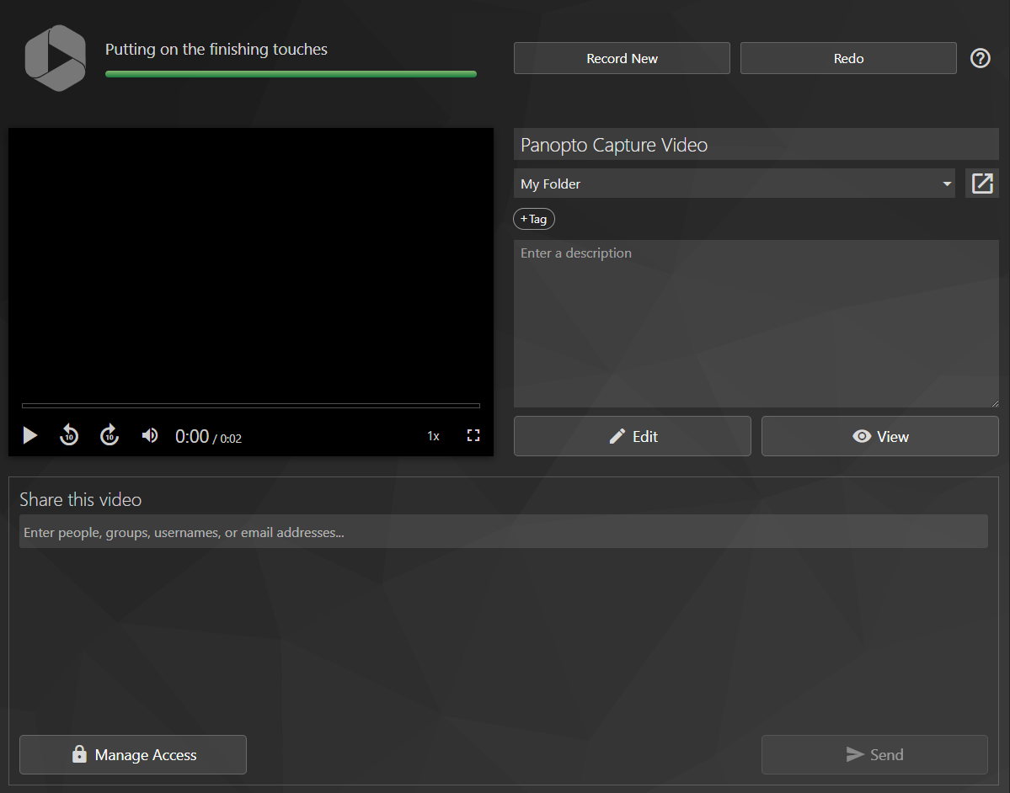

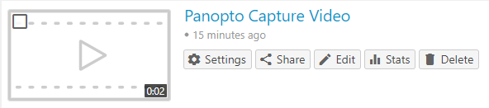
- If you tap the arrow in a box icon to the right of the location dropdown menu, you will be taken to your video in the designated folder location.

option 2: Upload a pre-recorded video to Panopto
- Capture recording with Panopto or other app and output as MP4, MOV, or WMV to your local computer.
- Log in to Panopto.
- Tap the red Create button at the top of the page, and select Upload media.
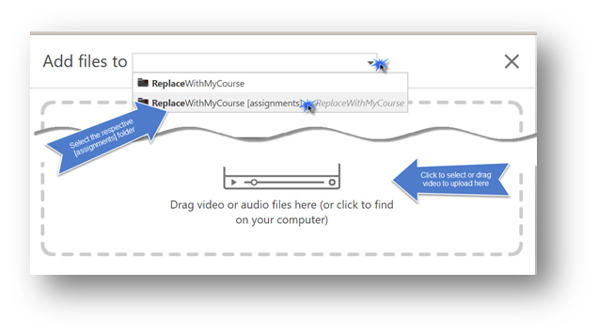
- Select the respective CourseName [assignments] folder and browse to select or drag your file into the dropbox.
- Allow the video to process and then, close the window as prompted.

For additional instructions, tap here to view video support provided by Panopto.

option 3: Capture & publish with the Panopto Recorder App
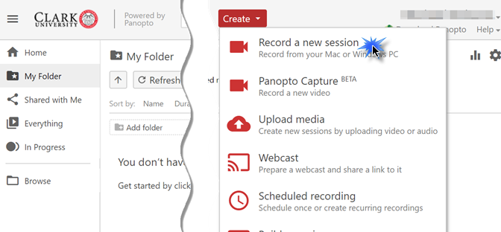
With Panopto, you can easily capture and publish a video using the Panopto recorder app. The App is available for Mac, Windows, iOS and Android. Use the app to capture a PowerPoint presentation or other content on your screen.
- Log in to Panopto.
- Tap the red Create button at the top of the page, and select Record a new session.

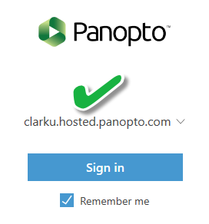
- Follow the prompts to download and install Panopto or begin recording.
- Launch the Panopto recorder app.
- Select clarku.hosted.panopto.com for the dropdown list.
- Sign in with Clark University Moodle.

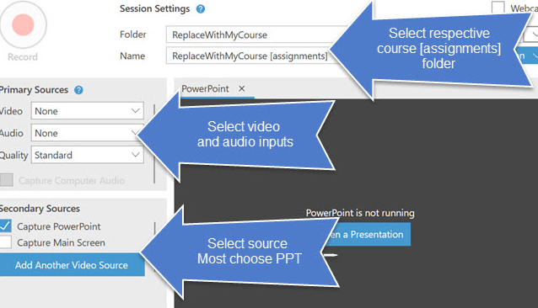
- Select the respective CourseName [assignments] folder to publish; choose input and sources. Record your video Panopto will begin to publish the content when you stop recording.

For information and platform-specific demonstrations, view the support content links below:
Apple/ Mac users:
Download and install app
Create a video

PC/Windows users:
Download and install app:
Create a video

Should you need help or more information contact the help desk via email at helpdesk@clarku.edu or call 508-793-7745.

