OWL Camera: Step-By-Step Guide
This is a comprehensive guide to using the Owl Camera, with Zoom, in a classroom. It will go over many steps including:
- turning on and logging onto the classroom PC
- turning on the projector
- logging onto Zoom
If you already know how to do these basic steps, visit our Owl Camera: Quick Start Guide or skip the first section of this document.
Please note that you do not need to touch the Owl Camera. It is on standby and we will turn it on through Zoom.

Getting started

logging onto the classroom pc
- Ensure the computer is turned on.
  - The power button for the PC is inside the cabinet.
  - The classroom PC is usually on, but may be on standby.
- Ensure the monitor is turned on.
- Wake up the computer by pressing the space bar until the monitor displays the Welcome screen.
- Press Ctrl-Atl-Delete on the keyboard.
- Log on to the PC with your Clark email and password.

start the projector
- Press the PC button on the podium panel.
  - You many need to press the button twice, once to wake up the panel and a second time to select PC.
- The projector screen will lower and turn on.

start zoom
- Tap on the Windows icon in the bottom left of the screen
- Scroll down to the Zoom folder, tap on Zoom to open.
- Tap Sign In.
- Tap Sign In with SSO.
- Enter clarku as the company domain.
- Tap Continue.
- A browser window will open.
- Sign into your Clark account using your Clark email and password.
- Tap Open when the pop-up window appears.
- In the Zoom window, choose your Class meeting.
- Tap Start.
Alternatively:
- Locate the Zoom link that you sent to your students.
- Tap on the link.
- Tap Open when the pop-up window appears.
- Tap Login in the small text that says If you are the host, please login to start this meeting.
- Tap Sign In with SSO.
- Enter clarku as the company domain.
- Tap Continue.
- A browser window will open.
- Sign into your Clark account using your Clark email and password.
- Tap Launch Zoom.
- Tap Open when the pop-up window appears.
- In the Zoom window, choose your Class meeting.
- Tap Start.

Setting up Zoom
The OWL Camera works just like a web camera that may be connected to your office PC, or your laptop.

setting up & checking audio
- Tap Join with Computer Audio.
  - Alternatively, tap Join Audio in the bottom left of the Zoom screen.
- Tap on the little arrow to the right of the Mute button in the Zoom window.
- For Microphone, choose Echo Cancelling Speakerphone (Meeting Owl Pro).
- For the Speaker, choose Echo Cancelling Speakerphone (Meeting Owl Pro).
- If you wish, test your audio.
  - Tap on the little arrow to the right of the Mute button in the Zoom window.
  - Tap Test Speaker and Microphone.
  - Follow the prompts.

starting the camera
- Tap Start Video.
  - If there are multiple cameras listed, choose Echo Cancelling Speakerphone (Meeting Owl Pro).
- Wait for the Owl Camera to start. This can take a couple of minutes.
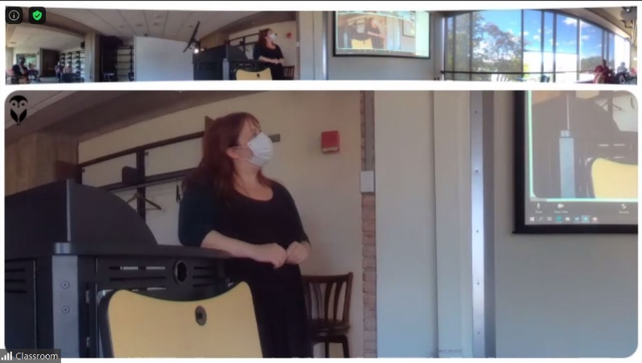
The Owl camera shot will show 2 – 4 panels:
Dynamic Panels,
based on audio points
360 View
There is always a 360 view of the room as the top shot.
The bottom panel will either be in 1, 2, or 3 sections depending on where the audio points in the room are. If three people are talking, or have spoken recently, in different parts of the room, the bottom panel will split in three to display those three locations. This all happens automatically.
Additionally, if the audio point moves slowly, the camera will pan to follow the sound.

Zoom RecommendationS

spotlight
It may be useful to Spotlight the Owl camera in Zoom, so that your remote students will always see the classroom as the largest participant camera on the screen. Note that spotlight only works if there are 3 or more participants (including the classroom) in the Zoom meeting.
- Hover over the video of the classroom video and tap the … (three dots that appear in the top right corner).
- Choose Spotlight video.
- To cancel the spotlight, tap Cancel the spotlight video in the upper left corner.

share screen
Just as with a regular Zoom meeting, with a regular web camera, you can both share your screen (PowerPoint, whiteboard, or other applications) while also having the Owl camera display the classroom feed in a smaller panel on the right side of the participant’s screens.
Should you need help or more information contact the Help Desk via email at helpdesk@clarku.edu or call 508-793-7745.

