OWL Camera – Quick Start Guide
This documentation is for those faculty who already feel comfortable with the basic classroom technology, and logging into and navigating Zoom. If you’re unsure on how to do any of these things, we recommend our OWL Camera – Step-by-Step Guide
Please note that you do not need to touch the Owl Camera. It is on standby and we will turn it on through Zoom. Should you need help or more information contact the Help Desk via email at helpdesk@clarku.edu or call 508-793-7745.

Setting Up Zoom
The OWL Camera works just like a web camera that may be connected to your office PC, or your laptop.
- For Microphone: choose Echo Cancelling Speakerphone (Meeting Owl Pro)
- For the Speaker: choose Echo Cancelling Speakerphone (Meeting Owl Pro)
- For the Camera: choose Echo Cancelling Speakerphone (Meeting Owl Pro)
  - The Owl camera can take a couple of minutes to begin displaying the classroom
The Owl camera shot will show 2 – 4 panels
360 View
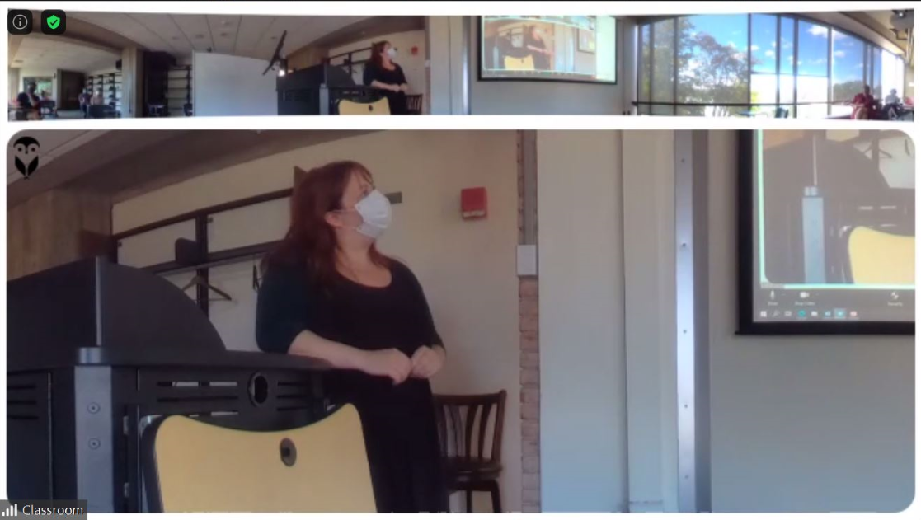
Dynamic Panels,
based on audio points
There is always a 360 view of the room as the top shot.
The bottom panel will either be in 1, 2, or 3 sections depending on where the audio points in the room are. If three people are talking, or have spoken recently, in different parts of the room, the bottom panel will split in three to display those three locations. This all happens automatically. Additionally, if the audio point moves slowly, the camera shot will pan to follow the sound.

Zoom Recommendation: Spotlight
It may be useful to Spotlight the Owl camera in Zoom so that your remote students will always see the classroom as the largest participant camera on the screen. Note that spotlight only works if there are 3 or more participants (including the ‘classroom) in the zoom meeting.
- Hover over the video of the classroom video and click the … (three dots that appear in the top right corner)
- Choose Spotlight video
- To cancel the spotlight, click cancel the spotlight video in the upper left

Zoom Recommendation: Share Screen
Just as with a regular Zoom meeting, with a regular web camera, you can both share your screen (powerpoint, whiteboard, or other applications) while also having the Owl camera display the classroom feed in a smaller panel on the right side of the participant’s screens

