Email Forwarding How-To Guide
  - Outlook for Web
Updated Spring 2023
Information Technology Services
helpdesk@clarku.edu

Set Up Email Forwarding

- In your internet browser, go to you.clarku.edu and sign in with your Clark credentials.
- On the left side of your ClarkYOU portal, click “Email” underneath the “Web Services” heading. You will be redirected to your Clark Outlook account.
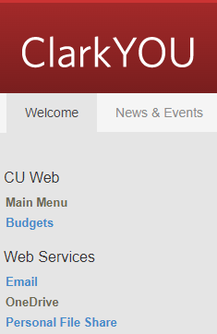
- In the upper right corner of the screen, click on the gear icon to access your settings.
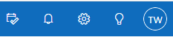

- At the bottom of the settings sidebar, click “View all Outlook settings.”
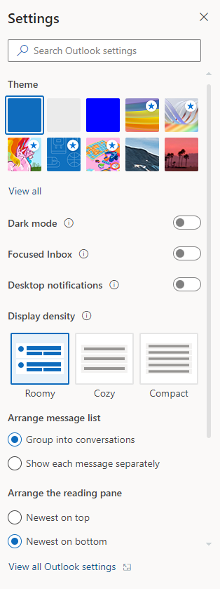
- In the pop-up window, select “Mail” in the left pane, and “Forwarding” in the middle pane.
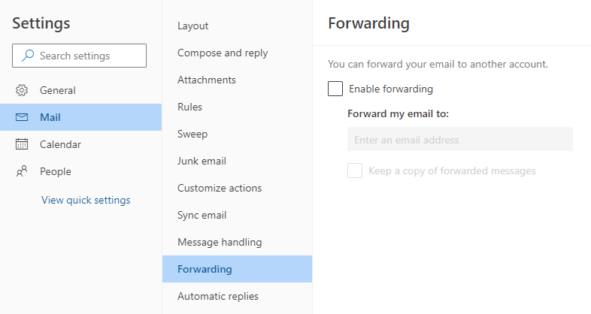
- In the right pane, check the “enable forwarding” box and then type in the email address you’d like your Clark email forwarded to, such as a personal Gmail, Yahoo, or Outlook account.
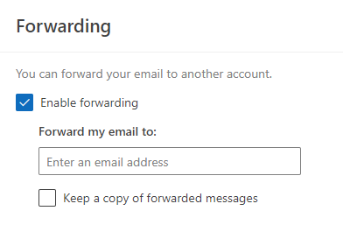
Tip: While optional, checking “keep a copy of forwarded messages” makes sure that your emails appear in BOTH your Clark account and the forwarding inbox. If left unchecked, incoming messages will only appear in the forwarding inbox and NOT in your Clark inbox.
- You are all set!
  - Please note: Emails forwarded from your Clark account may be sent to the spam folder of your personal mailbox. Be sure to check the spam folder and move any Clark messages to your inbox. You can also mark emails from clarku.edu as safe senders. Please contact helpdesk@clarku.edu if you’d like assistance.

Congratulations!
You have successfully set up email forwarding.
If you have any questions or issues, please contact helpdesk@clarku.edu

