How do I access Microsoft Teams?

Please note: ITS strongly recommends using the desktop version of Teams for the best experience.

Windows PC Desktop
- Click the Windows Start button in the lower right corner of your screen
- Using your keyboard, type “Microsoft Teams”
- Click on the app icon to open Teams.
  - If it does not appear, type in “Software Center.” You’ll be able to download and open Teams from there. Contact helpdesk@clarku.edu if you need assistance.
  - Tip: ITS recommends pinning Teams to your taskbar for easy access. To do this, locate the purple Teams icon on your taskbar and right click it. Then, select “Pin to taskbar.”
Mac Desktop
- Click the Finder icon located on the dock at the bottom of your screen
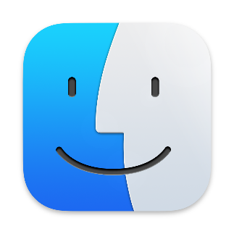
- In the Applications section, search for “Microsoft Teams.”
- Click the app to open Teams.
  - If you cannot locate the app in Finder, search in Applications for “File Wave” and click on it.
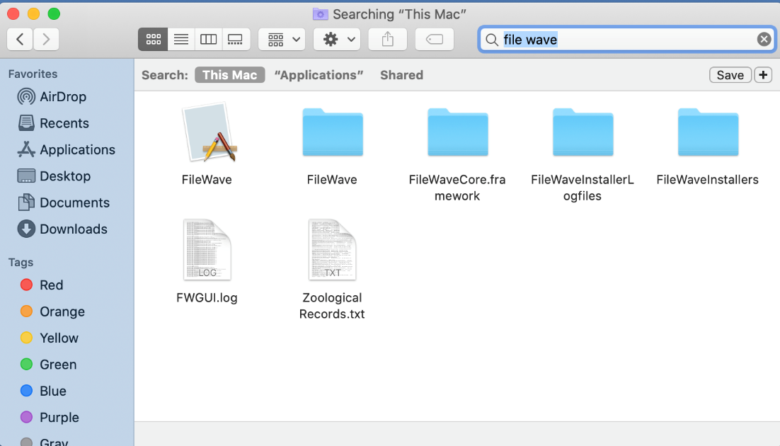

  - In the menu bar along the top of your screen, click the red wave icon and select “Install software.”
  - In the FileWave Kiosk window, select Teams to download the app.
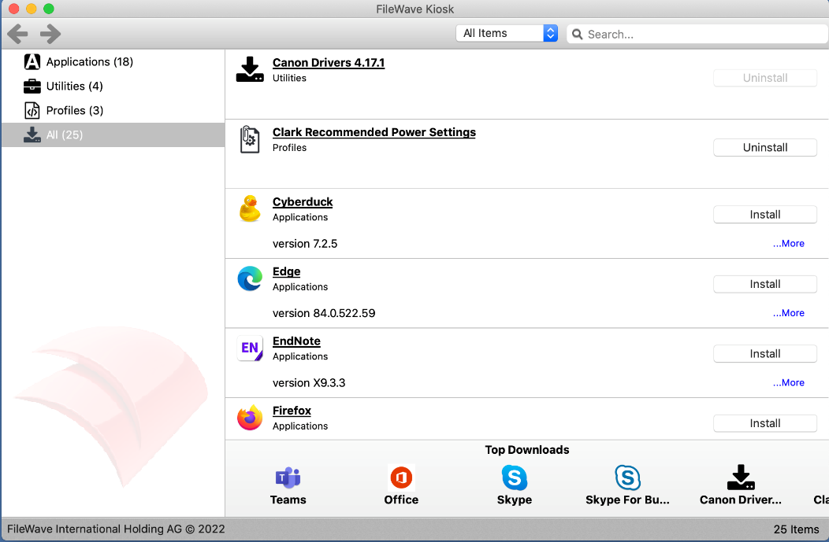
  - Tip: ITS recommends pinning Teams to your dock for easy access. To do this, right-click on the purple Teams icon once it appears in your dock and select “Pin to Dock.”
Online
- In your internet browser, navigate to you.clarku.edu
  - Sign in with your Clark username and password if necessary

- Under the Web Services menu on the left side of your screen, click OneDrive.
- Once your OneDrive account is open in another tab, click on the grid of dots located in the upper left corner of your screen.
- Click on Teams.
