OneDrive
  - How-To Guide
Updated Fall 2022
Information Technology Services
techtraining@clarku.edu

What is OneDrive?
OneDrive is Clark’s cloud storage system (for more information about the cloud, check out this article). Rather than saving files directly to your laptop or hard drive, OneDrive saves your files in a secure and encrypted corner of the internet set aside by Microsoft for Clark University. OneDrive can be accessed online through ClarkYOU. It can also be synced directly to your computer to appear as a storage location folder, much like the Downloads or Documents folder appears in File Explorer for PCs and Finder on Macs.
Why should I use it?
There are many benefits to using OneDrive, including:
- File protection if your computer fails or malfunctions
- Ability to access and edit files from multiple devices, including phones and tablets
- Integration with your Clark Outlook account
- Microsoft encryption and security for your files
- Easy collaboration with colleagues and peers

Table of Contents

Access OneDrive Online

Sync OneDrive to Computer
- PC
- Mac

Share with OneDrive
- Online
- On PC
- On Mac

Access OneDrive Online

- In your internet browser, go to you.clarku.edu and sign in with your Clark account information.
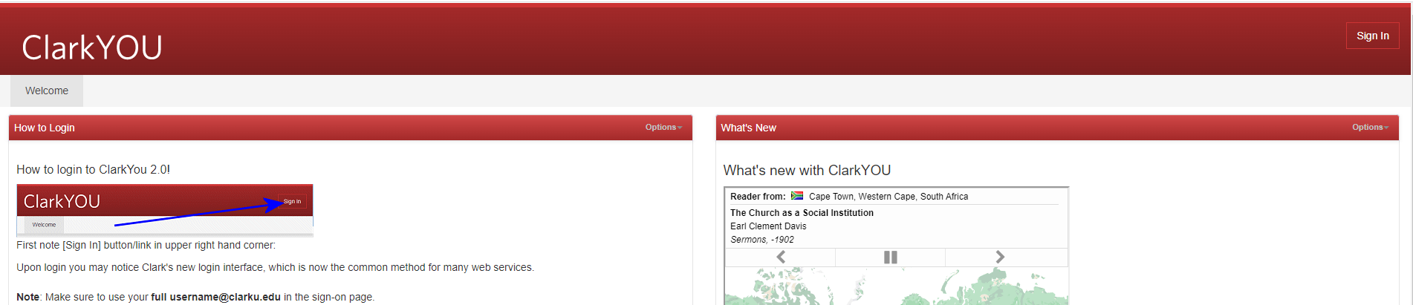
- From the Web Services menu on the left side of your screen, click on OneDrive.

- Arrive in your OneDrive account!
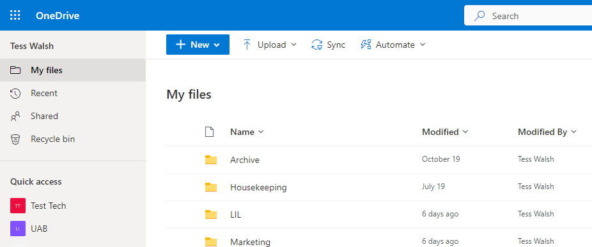
- From here, you can add or create new files/folders, view shared materials, and access shared libraries. Storing files here backs them up to the cloud for safekeeping and makes them easily accessible from multiple devices. You can also create a OneDrive folder on your device for ease of use (see below directions to Sync OneDrive to PC and Sync OneDrive to Mac). Contact techtraining@clarku.edu with any questions.

Sync OneDrive to PC

- From your OneDrive online account, click the Sync button in the tool bar.
- Click “Open Microsoft OneDrive” in the pop-up prompt from your internet browser.
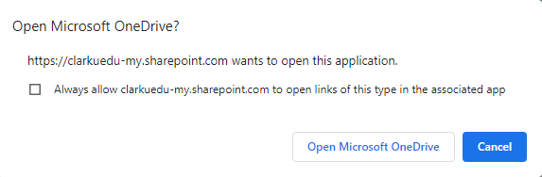
- A small OneDrive pop-up window will appear. If you don’t see it, check to see if anything on the bottom of your screen is flashing and click on it.

- Input Clark email address (if necessary) and click the blue Sign In button. You may also be prompted to enter your Clark password.
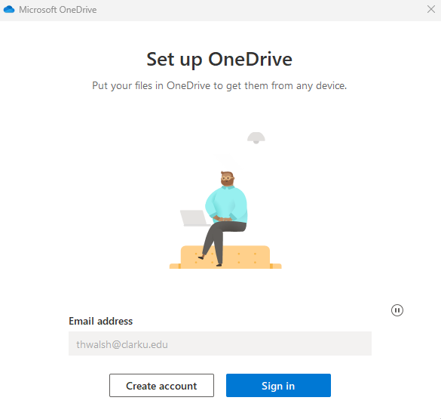
- You’ll see a few introductory messages from Microsoft. Click “Next” to navigate through these at your own pace.
  - If prompted to get the OneDrive mobile app, click “Not Now.”
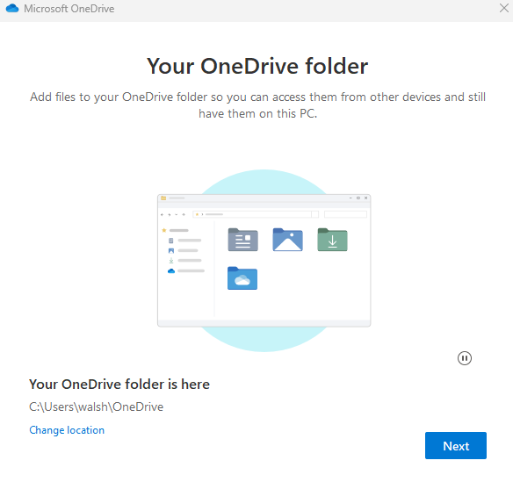

- Once OneDrive is finished setting up, click “Open my OneDrive folder.”
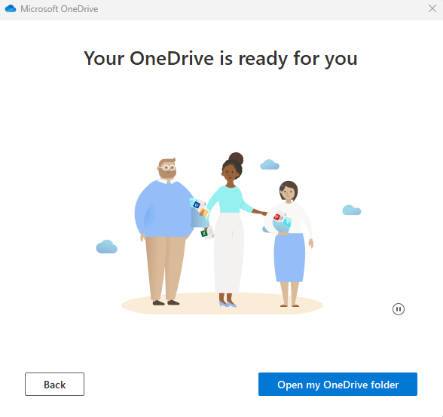
- The OneDrive folder will appear in File Explorer in the left menu pane. You can now save files directly to OneDrive from your device by selecting this location during the Save As process, or by dragging existing files/folders into the OneDrive location.
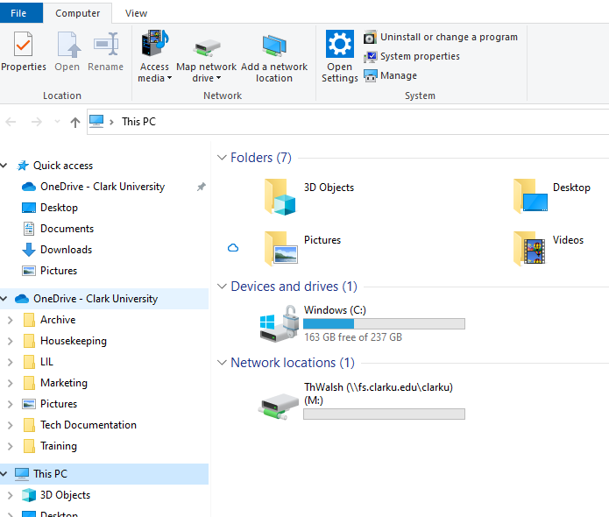

Sync OneDrive to Mac

- From the dock on the bottom of your screen, open Finder.
- In Applications, search for “OneDrive.” Double click on the app to open it.
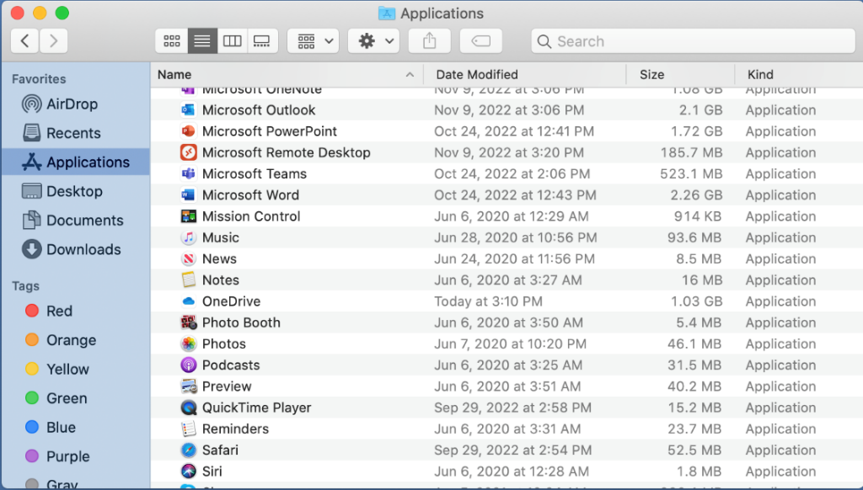
- Once OneDrive is open, you’ll be prompted to enter your Clark email address. Enter your entire Clark email address and click the blue “Sign In” button. You may be prompted to enter your Clark password as well.
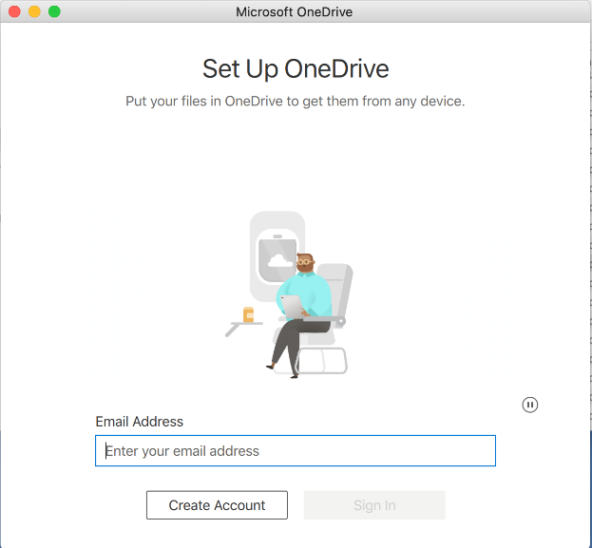
Sign In
- You’ll see a few introductory messages from Microsoft. Click “Next” to navigate through these at your own pace.
  - If prompted to get the OneDrive mobile app, click “Not Now.”
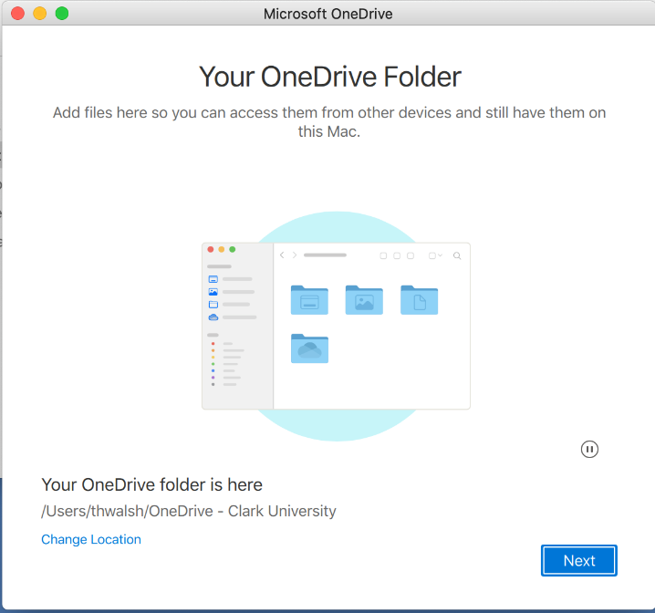
- Once you’ve clicked through the introductory messages, click “Open OneDrive folder.”
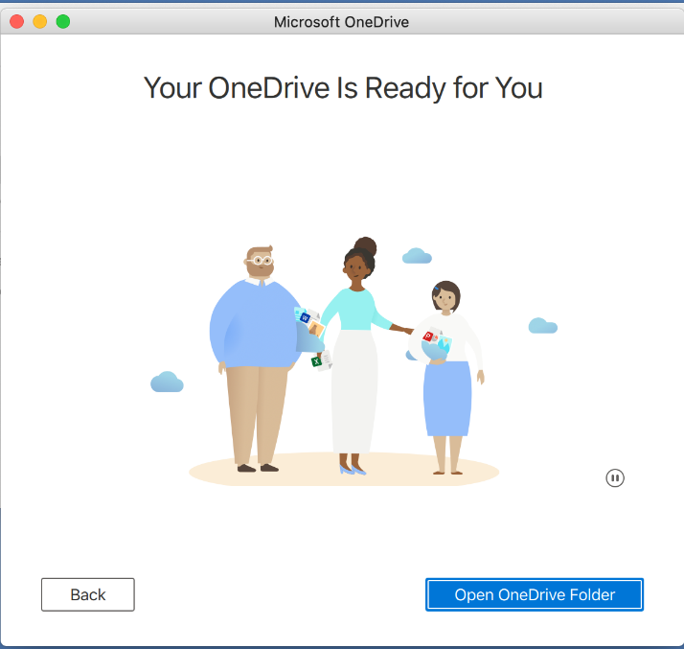

- OneDrive will now appear in the Finder window. You can now save files directly to OneDrive from your Mac by dragging and dropping them to this location, or selected OneDrive during the Save As process.
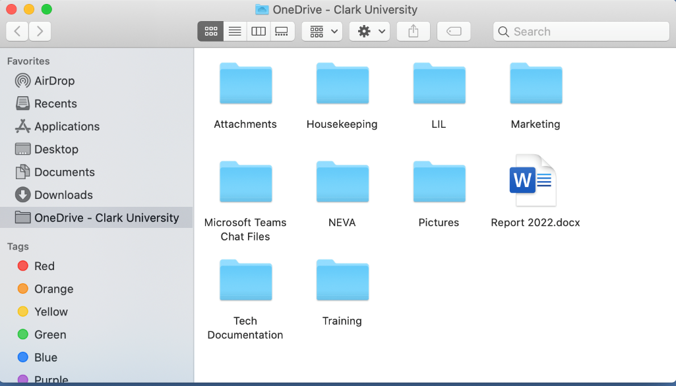

Share with OneDrive – Online

- Log into your OneDrive account online, following the steps in the “Accessing OneDrive” section of this document.
- Hover over the file or folder you’d like to share. Click on the arrow icon that appears.
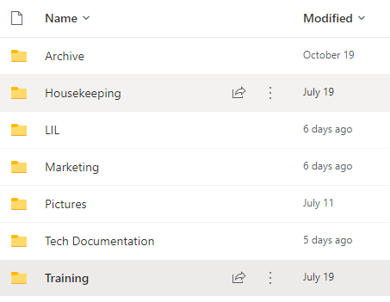
- You can opt to send link to document to specific people immediately via OneDrive, or copy link to send to people or larger groups later on in a Teams chat or formal email.
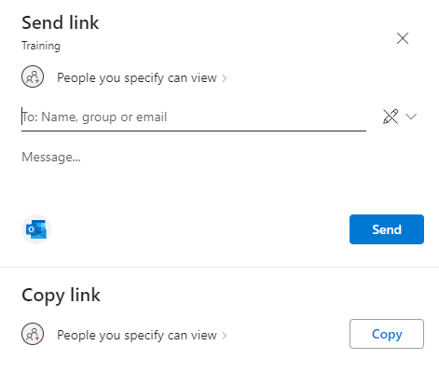
Tip: Send link is easier for quick check-ins with specific people or small groups. Copy link is easier for larger groups or if the file is part of a larger project that requires a more nuanced, detailed email.
- For either option, you can set permissions for the file by clicking “People you specify can view.”
- In the permissions window, you can choose which type of user can open the file’s sharing link and their level of access to the document (viewing, editing, or reviewing).
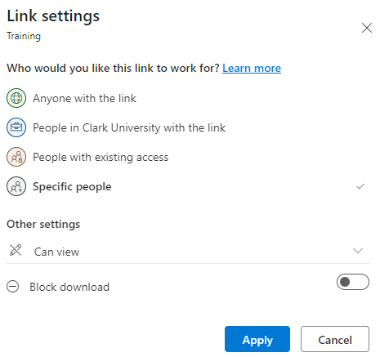
- Click “Apply” once you have made changes to permissions.

- Type in the name of the person/people you’d like to share it with, or select “copy link.”
  - If you send the link, the people you’re sharing the file with will receive a notification in Outlook.
  - Copying the link does not send any notifications: you need to send them the link.

Share with OneDrive – PC
Please note: you can only share specific files with this method, not entire folders. This method does not support sharing via link; files must be shared with specific people. The file you’d like to share MUST be saved to OneDrive in order to share it in this manner.

- Open File Explorer on your PC. It is located along the tool bar on the bottom of your screen.
- Go to the OneDrive section and open the file you’d like to share.
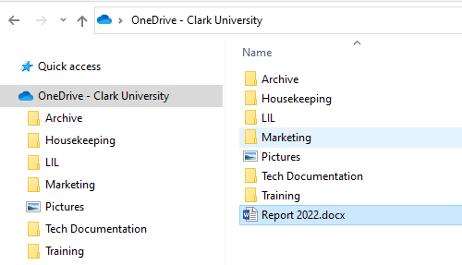
- Once the file is open, click on the “Share” button in the upper right corner.
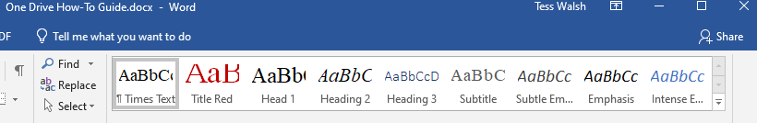
- Type in the specific people you’d like to share the file with and select their permission level. You can also include an optional message. Then, click “Share” to send the file to your colleague or group. They will receive a notification.
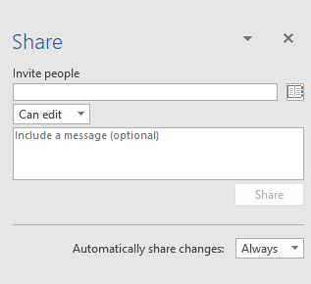

Share with OneDrive – Mac
Please note: you can only share specific files with this method, not entire folders. The file you’d like to share MUST be saved to OneDrive in order to share it in this manner.

- Open Finder. It is located along the dock at the bottom of your screen.
- Go to the OneDrive section listed in the left-side pane of the window and locate the file you’d like to share. Open the file by double-clicking on it. You may have to grant access to OneDrive to open an app such as Word, PowerPoint, etc.
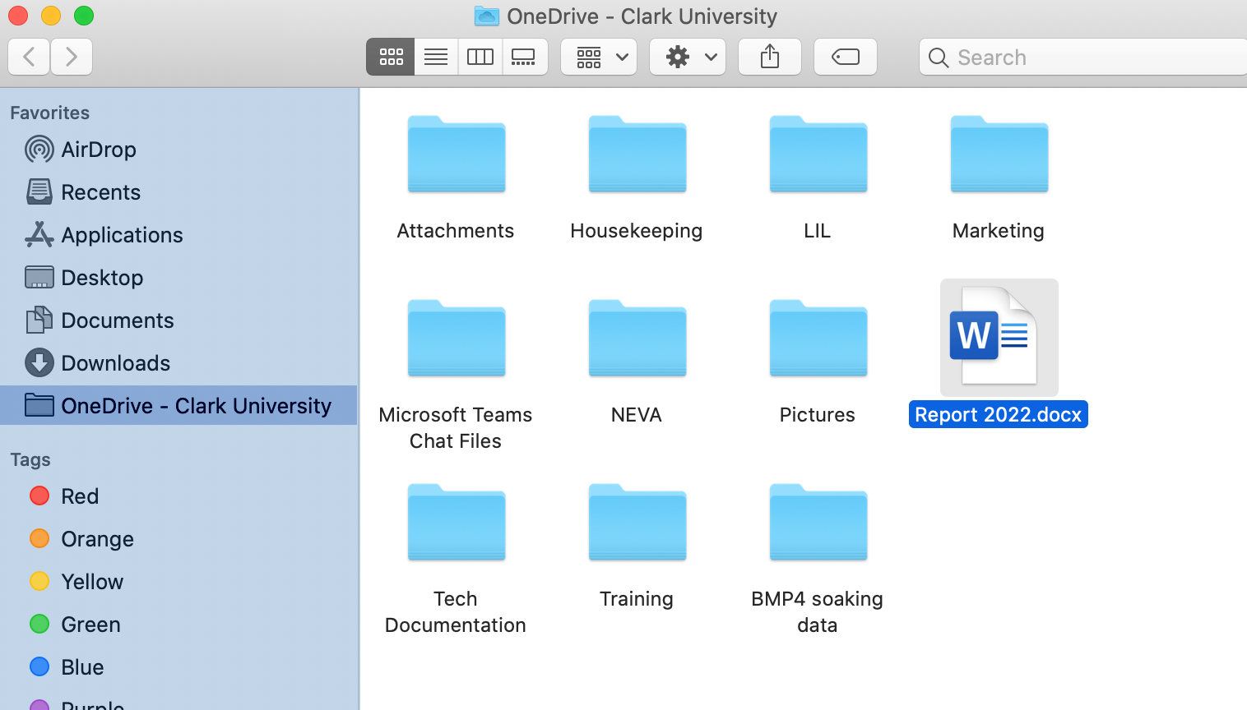
- Click the “Share” button in the upper right corner
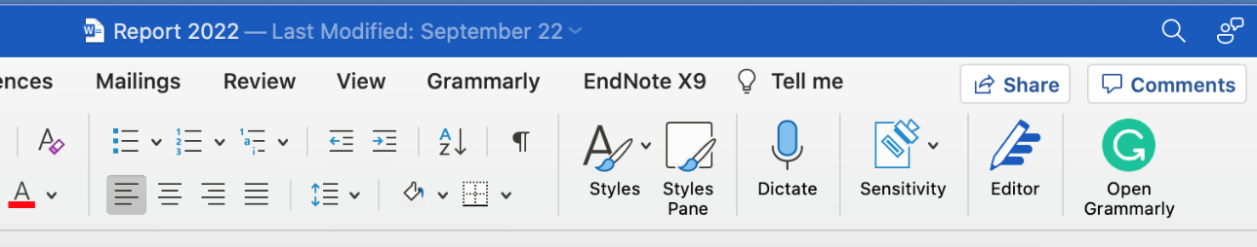
- You can opt to send link to document to specific people immediately via OneDrive, or copy link to send to people or larger groups later on in a Teams chat or formal email.
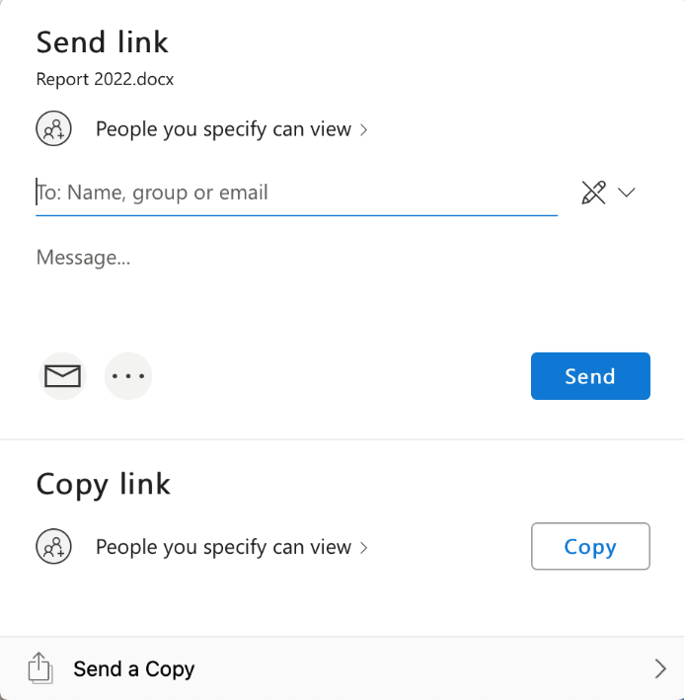
- For either option, you can set permissions for the file by clicking “People you specify can view.”
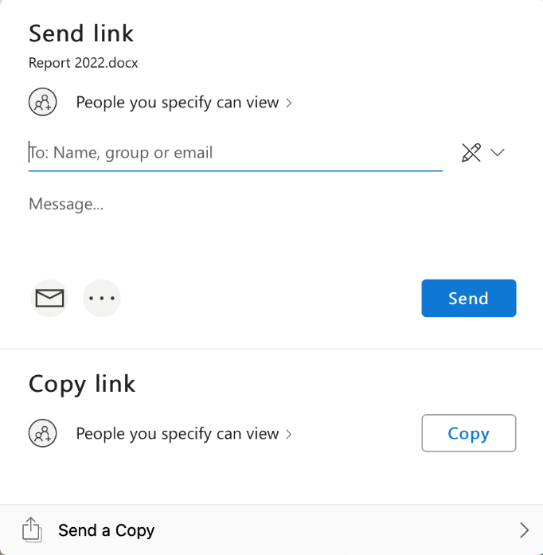
Tip: Send link is easier for quick check-ins with specific people or small groups. Copy link is easier for larger groups or if the file is part of a larger project that requires a more nuanced, detailed email.

- In the permissions window, you can choose which type of user can open the file’s sharing link and their level of access to the document (viewing, editing, or reviewing).
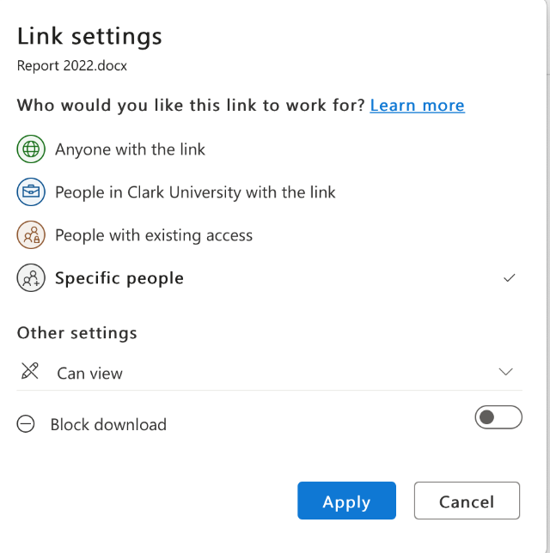
- Click “Apply” once you have made changes to permissions.
- Type in the name of the person/people you’d like to share it with, or select “copy link.”
  - If you are sending the link, write an optional message and click the blue “Send” button. The people you’re sharing the file with will receive a notification.
  - Copying the link does not send any notifications: you need to send them the link.

Congratulations!
You have successfully set up your OneDrive account
For questions or issues, please see book an appointment with the technology training specialist.

