Microsoft Bookings
  - How-To Guide
Updated Fall 2022
Information Technology Services
techtraining@clarku.edu

What is Microsoft Bookings?
Microsoft Bookings is an app within Microsoft Suite. Clark faculty and staff have access to this tool, which allows colleagues or students to book time on your calendar quickly and easily. Bookings reduces scheduling time and communicates with your Outlook calendar, so it will never book new meetings during times you've blocked off. It will also automatically add new meetings to your calendar once they have been booked.

Table of Contents

Accessing Bookings Through OneDrive

Create New Bookings Calendar

Set Up Services
- Edit Service
- Add Service
- Add Staff

Share Bookings Page

FAQ

Accessing Bookings Through OneDrive

- Go to your OneDrive account. In the upper left corner of the screen, click on the grid of dots.
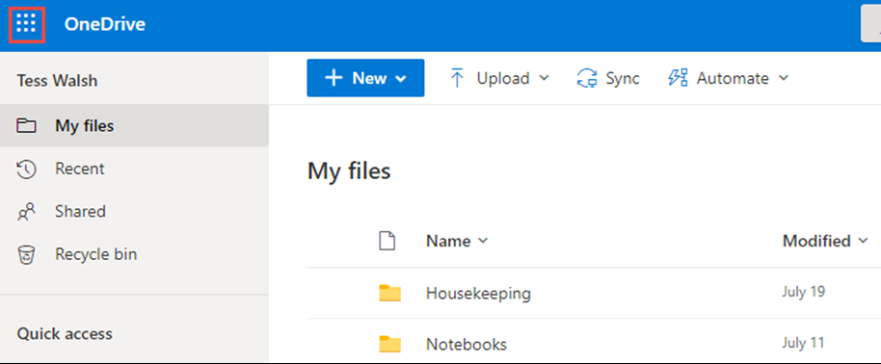

- In the Apps menu, click on Bookings. If you don’t see it in your menu, click on the “all apps” option towards the bottom and select Bookings from the full list of Microsoft apps in OneDrive.
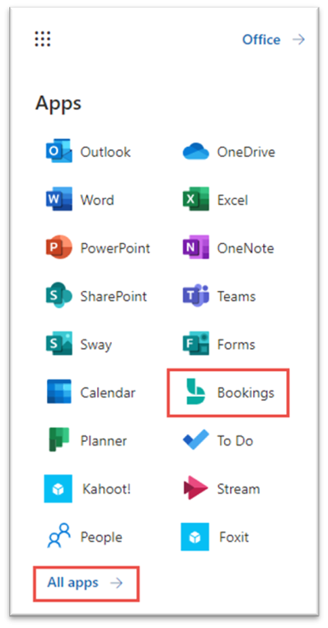
Create New Bookings Calendar

- Enter a name for your Bookings page (this can be changed later if necessary). Set your “business house” as your typical working hours during the week
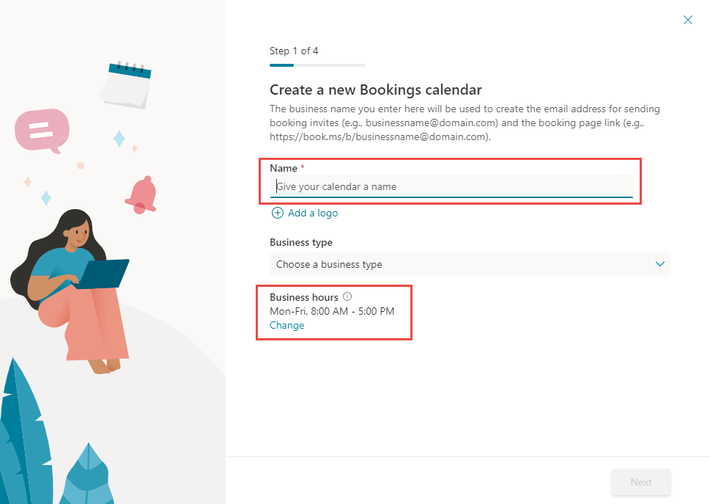
- Next, add staff to your Bookings calendar (if necessary). Staff are those who are “bookable” for appointments. Type in the name of anyone you’d like to add (you can also add them later). If you are creating a Bookings page for just yourself, skip this step by clicking “Next.”
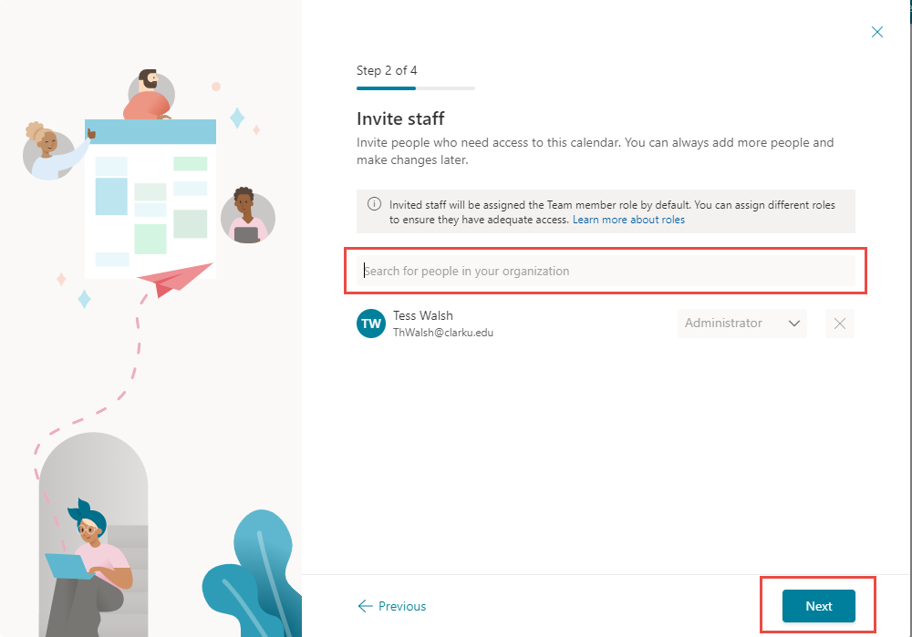

- Add a service to your Bookings calendar. You can think of “services” as meeting types. The default is a 30 Minute Teams meeting. You can change this, or click Next to move on. You will be able to edit and add different services later.
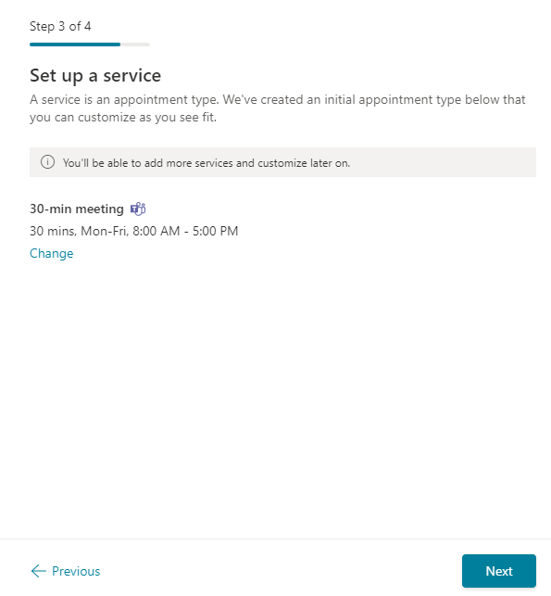
- Select who can book appointments with you. ITS recommends selecting the middle choice – “people in my organization.” This means that only people with Clark accounts will be able to book time with you. Finally, click “Create calendar” and wait as Microsoft sets up your Bookings.
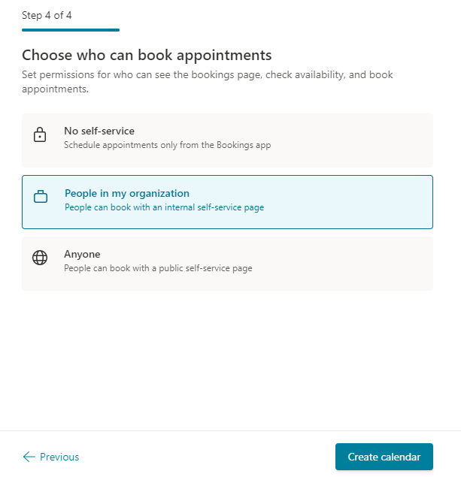

Set Up Services

- Once your calendar is ready, click the “Get Started” button.
- In your Bookings calendar, you’ll see a menu on the left side. Click on “Services.”
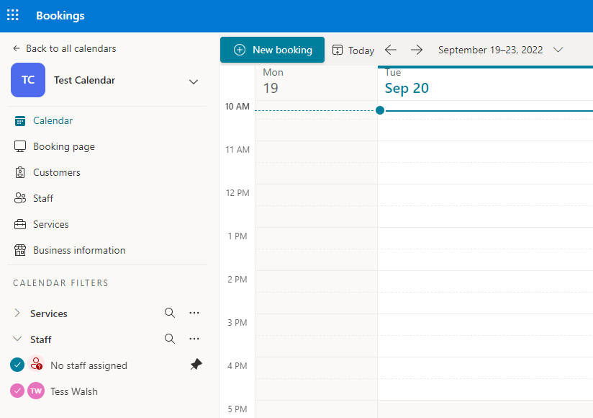
- To edit a service, click the pencil icon next to “Edit services.” This action will allow you to set multiple aspects of your meeting types, including duration, location, and required questions.

- There are several options for editing a service, which are listed on the left of the pop-up window. The first is basic details. In this section, you can name the service, write a brief description, set the duration, and add an online meeting. 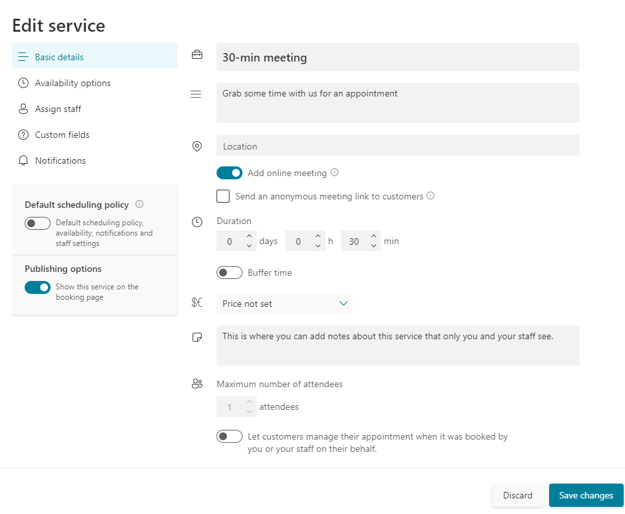
Note: all online meetings in Bookings are automatically located in Teams
Tip: Do not click Save Changes until you have completed all Edit Service steps.
- In the next section, Availability options, select the minimum and maximum lead time for booking and the hours during which students and colleagues can book time with you.
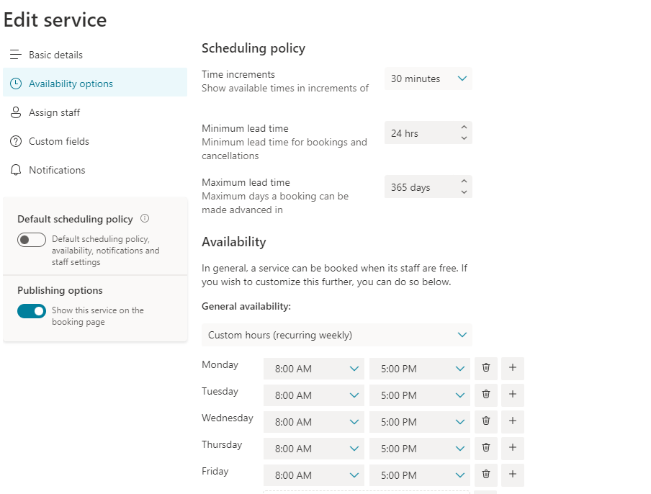

- In the Assign staff section, select staff members for the service by clicking the circle next to names.
  - If you need to add staff members, please see directions on Adding Staff.
  - If you are the only person using the Bookings page, TURN OFF the “allow customers to choose” option
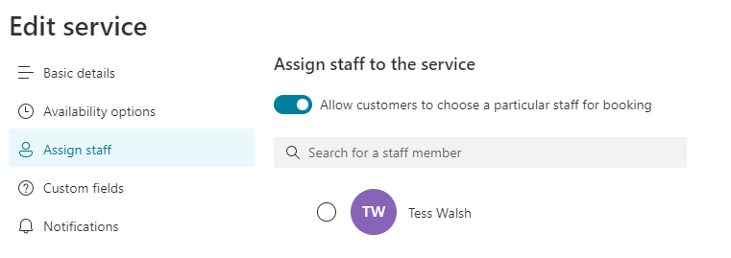
Be sure to select yourself as staff
- In the Custom fields section, you can customize which questions/information will be collected when someone books an appointment with you. The checkmark indicates the question will appear on the Booking page. The toggle on the right indicates whether it is required. You can select or turn off questions and requirements by clicking on them.
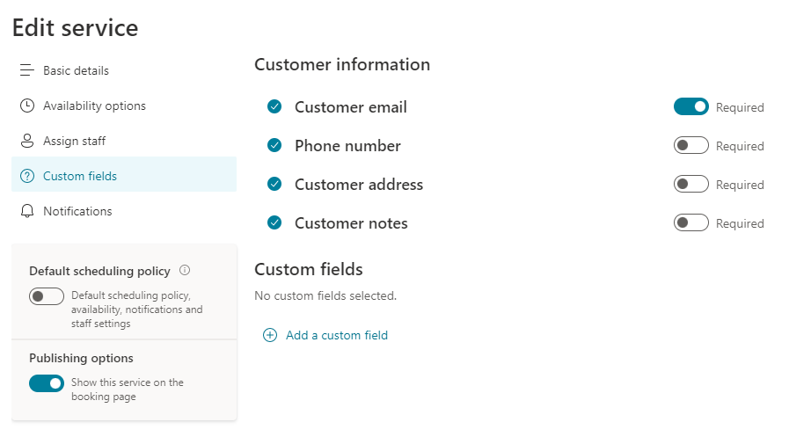
Toggle
Checkmark

- To write your own questions, first click on “Add a custom field.”
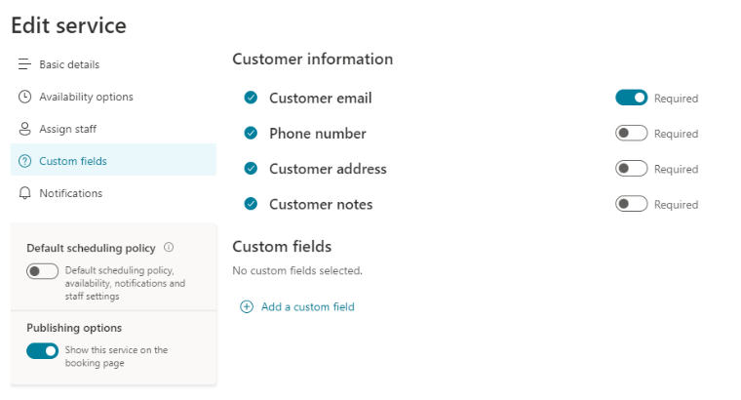

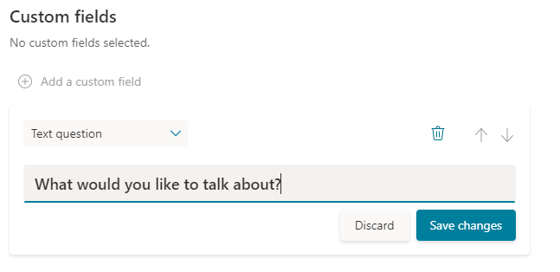
- Write your question and click the “Save changes” button immediately below the text box. Click on the circle and toggle to display/require the question as necessary.

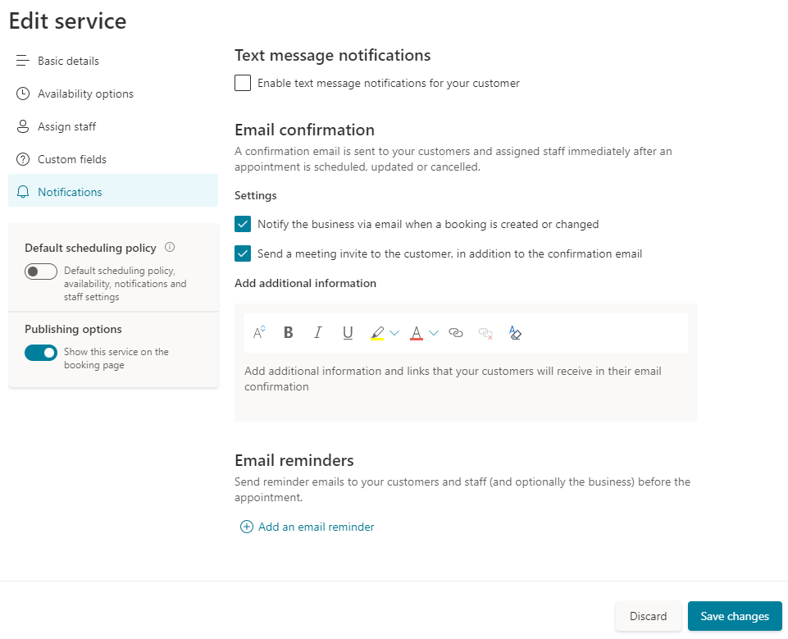
- The last option in Edit service is Notifications. Here, choose if you’d like to automatically send meeting invitations or receive email notifications. When you are done with this section, click “Save changes” at the bottom of the pop-up window

- To add a service, go to Services within Bookings menu. Click “add new service.” Follow the previous steps to set up as desired.
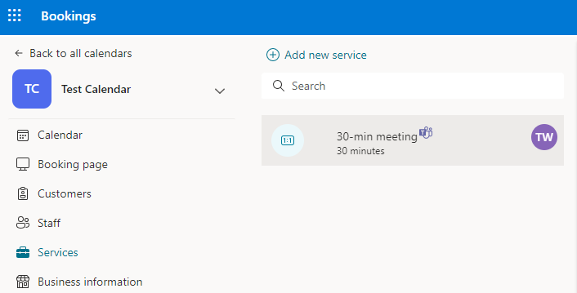
- To add staff, select “add new staff” within the “Staff” menu option. Then, assign staff to services as necessary. You may have to go back to Edit Service – Staff to assign staff members to the correct services/meeting types.
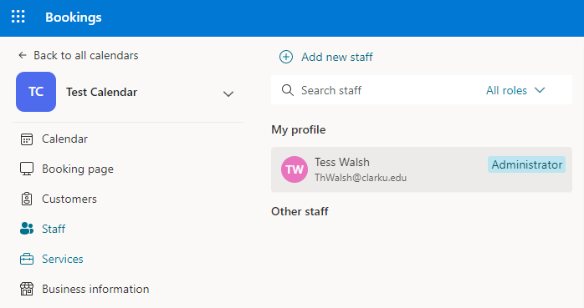

Share Bookings Page

- From the Bookings menu, select “Booking page.” From here, you can copy the link to your Bookings page, click on it to view the page, email it to others, etc.
Tip: Add your Booking page link to your email signature

Congratulations!
You have successfully set up your Bookings page
For questions or issues, please see FAQ section of this guide or book an appointment with the technology training specialist.

FAQ & Common Issues

Should I set up additional services?
Setting up additional services allows greater flexibility for both you and anyone trying to book time with you. For example, Bookings users often set up different services such as “1 Hour Online Meeting” or “1 Hour In-Person Meeting.” You can also create meetings for different purposes, such as advising, office hours, troubleshooting, etc.

How do I customize the look of my Bookings page?
In the Bookings menu, select “Booking page.” Scroll down to click on the “Customize your page” option.

My calendar is grayed out and unbookable
First, make sure to select a service or meeting type before trying to choose a date. If the issue persists, go to Edit service and make sure you are listed as staff for all meeting types within your Bookings calendar. Please reach out to techtraining@clarku.edu if you need assistance.
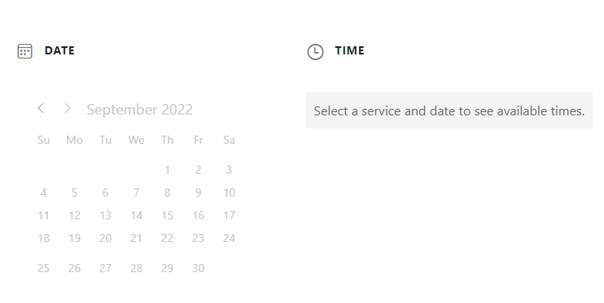

My calendar is showing the wrong times
In the Bookings menu, go to the “Bookings page” section. Scroll down and select “region and time zone settings.” Type or select a city within the Eastern Time Zone.

