Multi-Factor Authentication (MFA) Set Up Guide

Updated Summer 2023
Information Technology Services
helpdesk@clarku.edu

What is multi-factor authentication?
To learn more about MFA, please click here to view a short video.
What are my MFA options?
ITS strongly recommends using Microsoft Authenticator, an app available for download on mobile devices such as smartphones. Once set up, this method will send you a notification on your phone when it needs to verify account access. This method ensures you will be able to access your account anywhere with an internet connection, and it also provides a higher level of security.
If you do not have a smartphone, you can set up MFA through SMS authentication using your cell phone. This method sends a one-time code through SMS (text) messaging when it needs to verify account access, which you then enter into your computer. The code will be different each time and should not be shared with anyone, including members of ITS.
If you do not have a smartphone or a phone capable of receiving text messages, please contact helpdesk@clarku.edu.
What do I need?
If you’re using the Microsoft Authenticator app, you’ll need:
- Your smartphone
- Internet access
If you’re using SMS authentication, you’ll need:
- Your cell phone
- A computer with internet access
Table of Contents
Set up MFA with the Microsoft Authenticator App
Set up MFA with SMS Authentication

Microsoft Authenticator App

- Download the Microsoft Authenticator app to your smartphone using either the Play Store (for Android devices) or the App Store (for iOS devices).
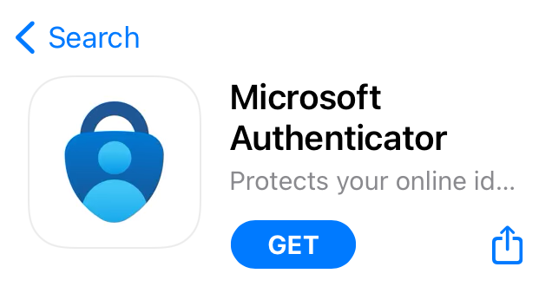
Check that the app you download was published by Microsoft corporation.
- Once the Authenticator app is downloaded to your smartphone, tap the app to open it.
- The app will ask to send you notifications: these notifications will help you authenticate your account moving forward. Tap Allow.
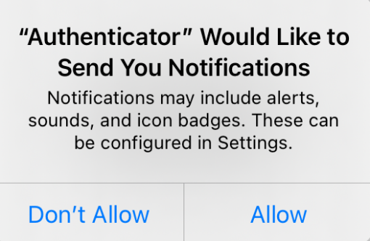
- Tap Accept, then tap Continue.
- Tap Add work or school account, then tap Sign in.
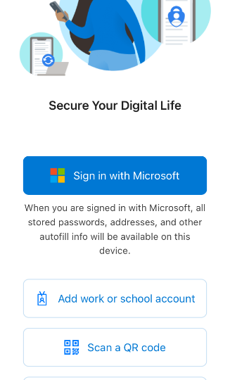
- Log in using your Clark University email address and password.
- When prompted to finish setting up on a web browser, tap Open browser.
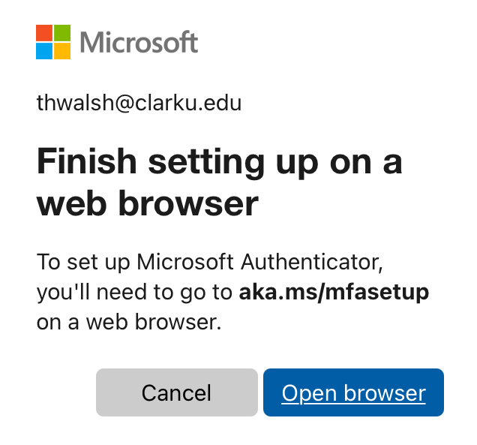
- Microsoft will alert you that more information is required. Tap Next and enter your Clark account credentials.
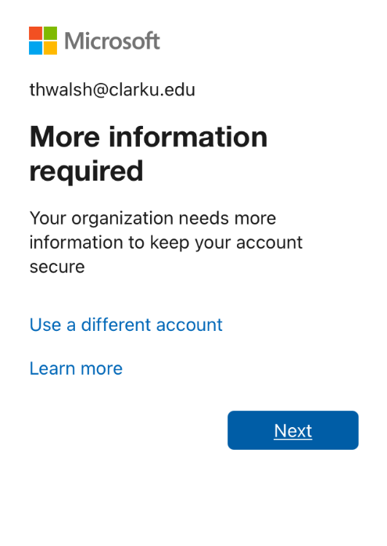

- Next, you’ll see a screen instructing you to get the Microsoft Authenticator app. Since you have already downloaded it to your smartphone, tap Next.
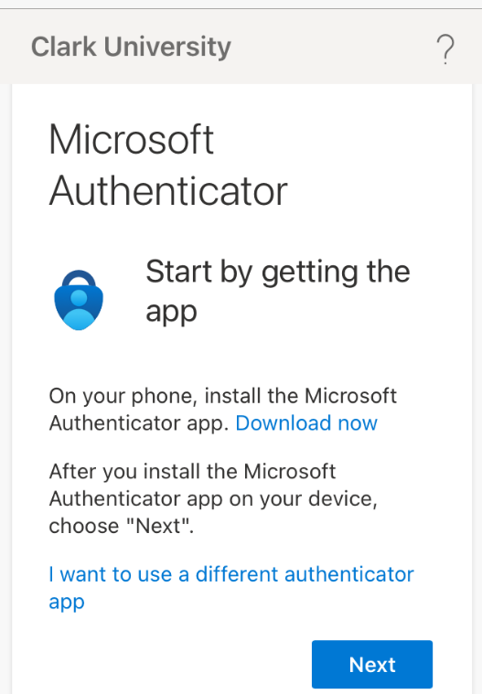
- The following screen will prompt you to set up your account in the Microsoft Authenticator app. Tap Pair your account to the app by clicking this link, and then tap Open.
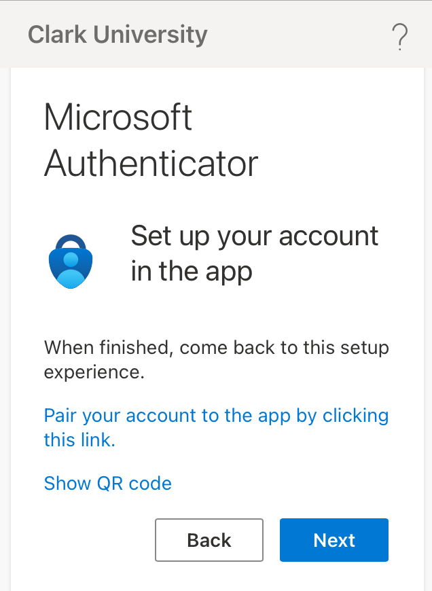

- Microsoft Authenticator will likely enable App lock, meaning that you will need to enter your TouchID or phone passcode in order to access the app. You can change this in settings if you’d like. When prompted, tap OK.
- You’re all set! The next time Microsoft needs to authenticate your account access, you’ll receive a notification on your phone. You can manage MFA options by visiting https://mysignins.microsoft.com/.
  - Please note that you will not be prompted for MFA while on campus or when connected to the VPN.

SMS Authentication

- On your computer, navigate to https://outlook.com/clarku.edu using your internet browser. Log in with your Clark University username and password.
- Microsoft will alert you that more information is required. Click Next.
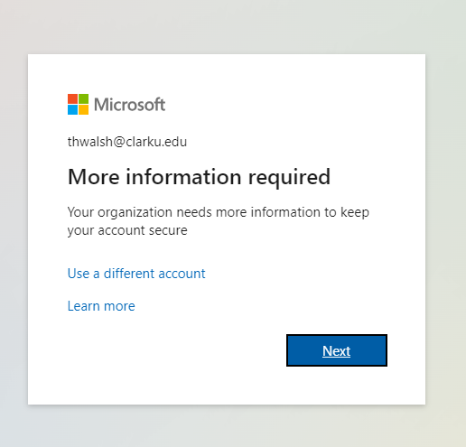
- Since Authenticator is recommended by both Microsoft and Clark’s ITS department, you will see the app suggestion on your screen. Click I want to set up a different method at the bottom.
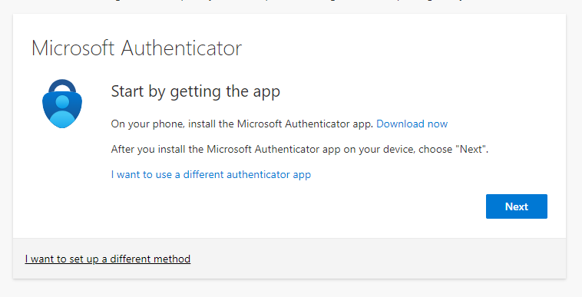
4. In the pop-up window, select Phone, then click Confirm.
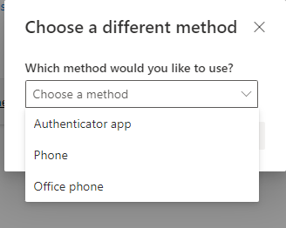
- Enter your cell phone number and select Text me a code. Then click Next.
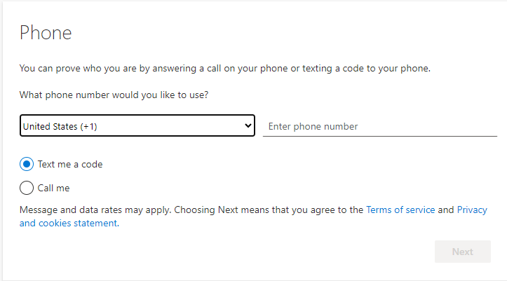
Remember: Microsoft will text this number a new code each time it needs to verify your account access. Never share any of the codes you receive.
- Once you input your cell phone number, Microsoft will text you a code. Enter the code when prompted and click Next.
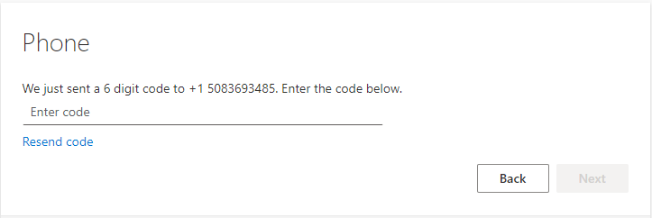
- Once your phone is registered successfully, you’ll see a green check mark. Click Next, then click Done.
- You’re all set! The next time Microsoft needs to authenticate your account access, you’ll receive a code via text message on your phone. You can manage MFA options by visiting https://mysignins.microsoft.com/.
  - Please note that you will not be prompted for MFA while on campus or when connected to the VPN.

