Set Up Microsoft Authenticator for MFA: How-To Guide

Clark University
Updated April 2023
Information Technology Services
Helpdesk@clarku.edu

Note on MFA
Multi-factor authentication (MFA) is an important security measure that ensures you—and only you—have access to your Clark account. There are numerous MFA methods: most require a secondary device, such as a smart phone. Click here to watch a short video to learn more about MFA.
ITS strongly recommends using the Microsoft Authenticator app to verify access to your Clark account. This can be added to multiple devices, such as smart phones or tablets. For security purposes, add the app to devices that only you use (not to shared devices). If you do not have such a device, or would like to set up MFA another way, please contact helpdesk@clarku.edu.
Install App on Android
- Open the Play Store and search for “Microsoft Authenticator.”
- Tap Install. Wait while the app installs, then tap Open.
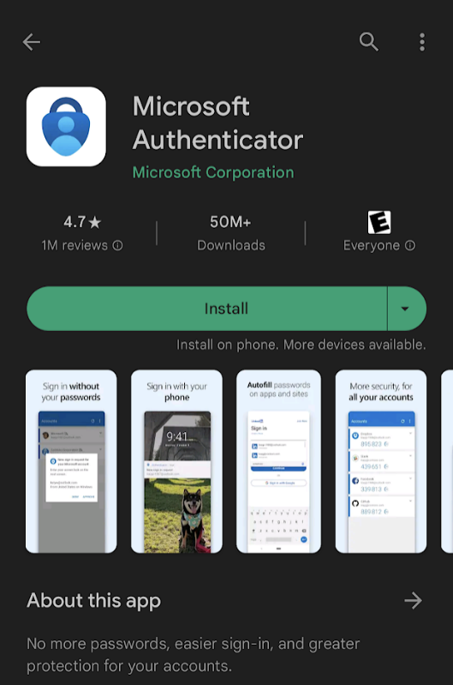

- Tap Allow when the app asks to send notifications. This permission will let the app send you a notification to approve or deny whenever your Microsoft account is accessed from a new device.
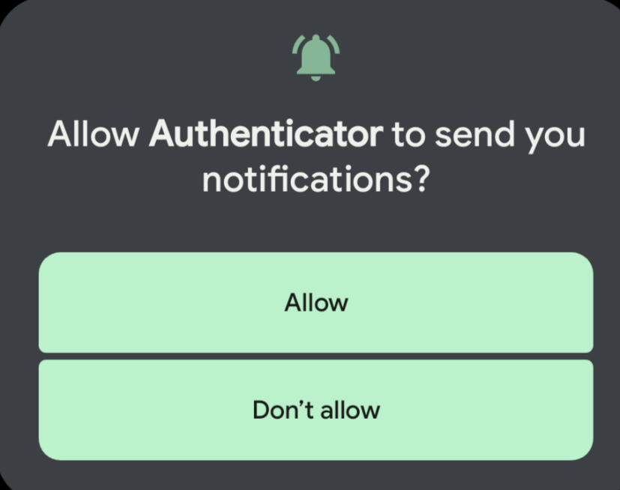

- When the app opens, tap Accept and then Continue.
- Tap Add work or school account.

- Tap Sign in
- Enter your Clark email address and password.
  - Please note: if you have MFA set up another way (such as through text), you may need to verify your account with that method before proceeding.
- On the Account Added confirmation screen, tap Finish.
- You’re all set! The next time Microsoft needs to verify your account access, you’ll receive a notification on your phone which you can approve or deny.

Install App on iOS
      - Open the App Store and search for “Microsoft Authenticator.”
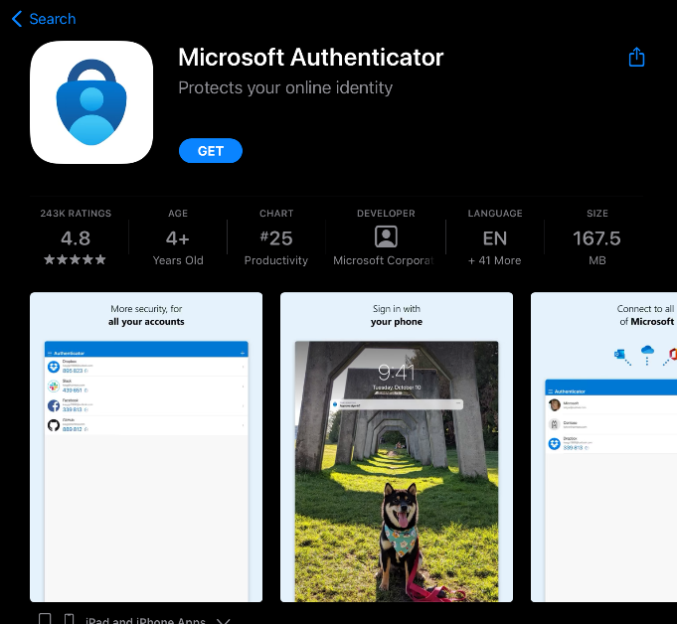
      - Tap Get. You may have to enter your Apple ID or scan your fingerprint. Once the app downloads, tap Open.
      - Tap Add school or work account.
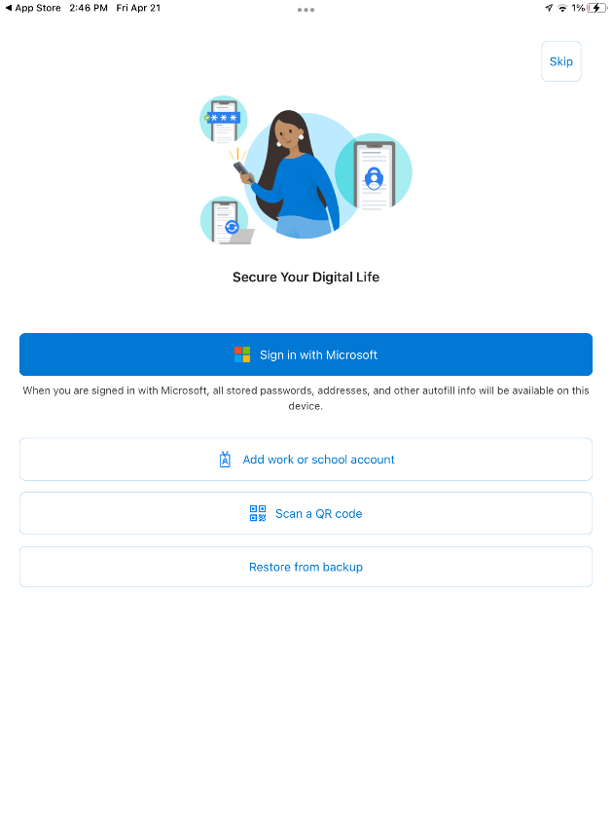

      - Enter your Clark email and password.
        - Please note: if you have MFA set up another way (such as through text), you may have to verify your account with that method before proceeding.
      - On the “Account added” confirmation screen, tap Finish.
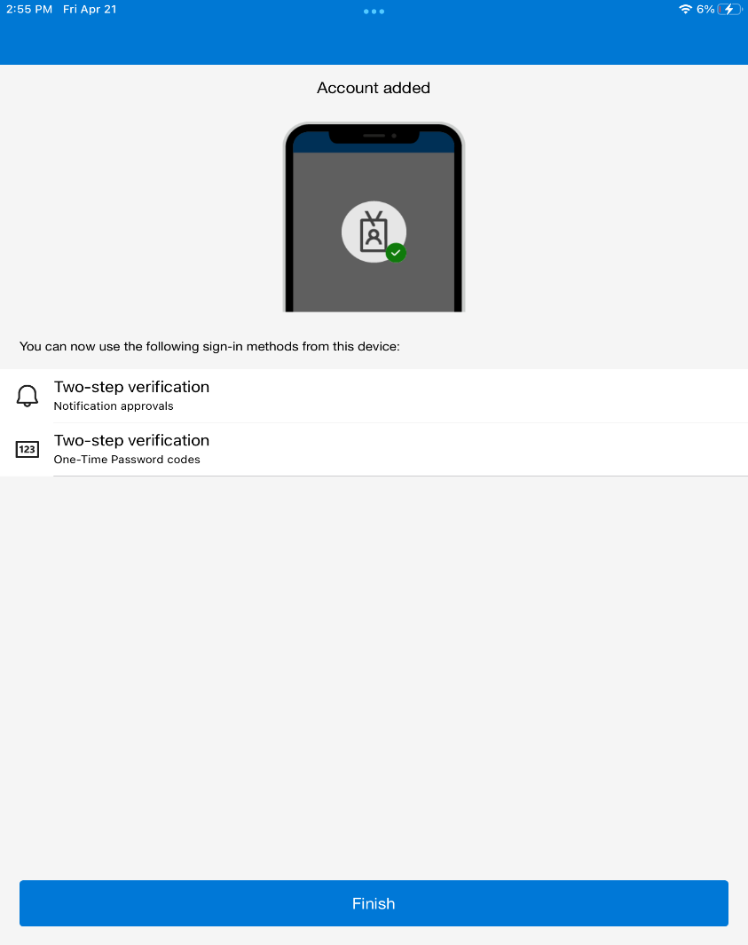

      - Tap Allow when the app asks to send notifications. This permission will let the app send you a notification to approve or deny whenever your Microsoft account is accessed from a new device.
      - You’re all set! The next time Microsoft needs to verify account access, you’ll receive a notification.

