Information Technology Services 950 Main Street
Worcester, MA 01610-1477

Mapping a File Share
Connecting a Mac OS computer to a networked folder of shared files

Introduction
(508) 793-7745 Phone
(508) 793-8823 Fax
www.clarku.edu/its

You need to know your Clark Account username and password, full path to the file share and be connected to the internet. If you are trying to connect from off campus, you will need to be connected to the Clark VPN prior to following these instructions.
If you need help setting up VPN first, click here to view directions.

Setup Steps
- With the “Finder” active, click on the “Go” menu to open a drop-down menu. Select “Connect to Server…”
- In the “Server Address:” text field, type the full name of the share using the following:

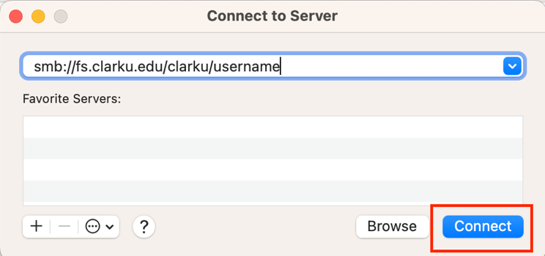
smb://fs.clarku.edu/clarku/username
for staff/faculty personal directory

smb://fs.clarku.edu/dept/
followed by your department code/folder name for departmental shares

smb://fs.clarku.edu/research/
followed by the faculty username/folder name for research shares

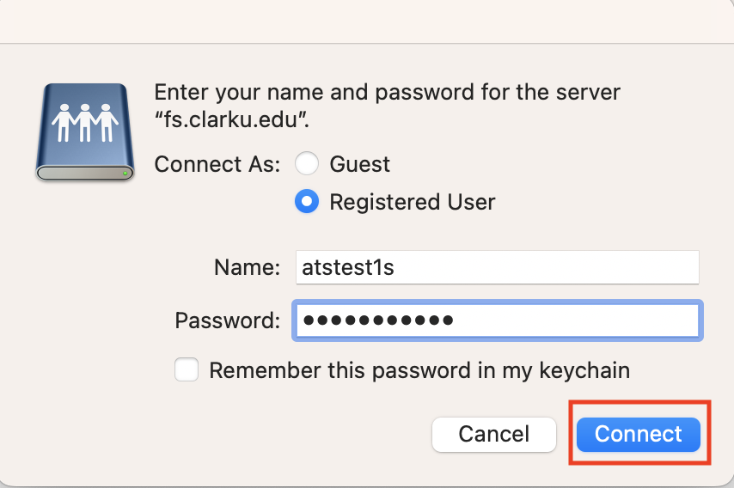
smb://fs.clarku.edu/class/
followed by class folder information for class shares
- Click the “+” button to save path to Favorite Servers
- Select the file share and click “Connect”.
- As the connection is established, you will be asked for your Clark Account credentials.
  - Enter your Clark email address, “username@clarku.edu” in the “Name” field.
  - Enter your Clark Account password in the “Password” field.
  - Select “remember this password in my keychain” unless you are using a public or lab device.
  - Click “Connect.”

