Request a Clark University Mailing List

Clark University
Updated July 2023
Information Technology Services
Helpdesk@clarku.edu

What is a mailing list?
A mailing list allows you to email a group or department all at once, without remembering and selecting each individual’s Clark email address. Subscription options, archives, and other options are all managed by the list owner (typically, the person requesting the mailing list becomes the list owner, although additional owners can be added later on).
Request a New Mailing List
- In your internet browser, go to http://lists.clarku.edu/. In the upper right corner of the screen, click Clark Login.
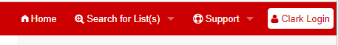
- Enter your Clark username and password (if required).
- Click Create list.
- In the List name field, enter the name you’d like to use for the mailing list. Note: the name will be part of the mailing list’s email address, so it can only contain letters, numbers, underscores, or dashes.
  - Example: Typing “iloveclark” will create iloveclark@lists.clarku.edu as a mailing list.
iloveclark
- Next, you’ll select a list type. Descriptions of each type’s subscription and archive options are listed beneath each list type. Choose the one that best suits your mailing list by clicking the appropriate bubble.
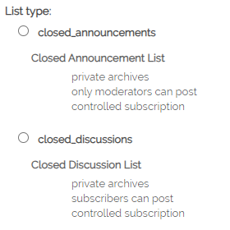
- In the Subject box, enter a human-friendly name for your mailing list.
  - Example: the human-friendly name for “iloveclark” would be “I Love Clark.”
I Love Clark
- In the Audience field, select the option that best matches the purpose of your mailing list.
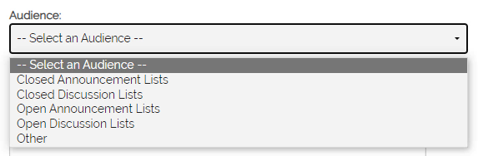
- In the Description field, enter a brief description of the mailing list’s purpose.
A mailing list for Clark community members who want to share stories, pictures, or tidbits about why they love Clark!
- Click Submit your creation request.
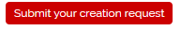
ITS will contact you within 2-3 business days regarding the status of your mailing list request. If you have any questions, or if you’d like assistance with this process, please contact the ITS Help Desk at 508-793-7745 or helpdesk@clarku.edu.

