Guidelines for Poster Design

Contents
Designing your Poster 2
Design Steps 3
STEP 1. Planning 3
STEP 2. Setting Up the Poster Size 3
STEP 3. Designing the Poster Layout 3
STEP 4. Adding Content 4
STEP 5. Customizing the Design 4
STEP 6. Proofreading & Reviewing 4
STEP 7. Saving & Printing 5
Visual Guide: Set Up the Poster Size 6
Visual Guide: Organizing the Layout 7
Add boxes to organize information. 7
Group elements to easily move content. 7

For additional instructions: click here to access the ITS Explore Services page
Or, contact the ITS Help Desk: Helpdesk@clarku.edu

Designing your Poster
The information below contains suggestions for organizing your poster content and designing an effective poster. ITS recommends using Microsoft Powerpoint to design your poster as a single Powerpoint slide set up with the dimensions you want your poster printed in.

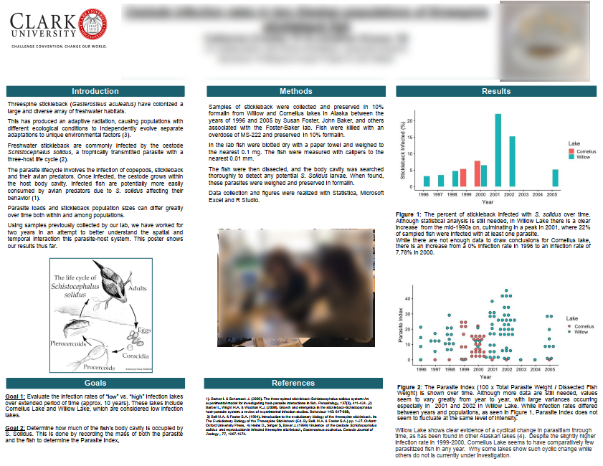

Standard poster dimensions are 36”x48”. We can print other sizes, but be sure that at least one side is either 36” or 42” to ensure optimal coverage.

Know your content. The most important goal in poster design is to convey information in a way that it is accessible and understandable. Every element on the poster, whether text or graphic, should be chosen and arranged to further that goal.
Know your audience. Will they be other scholars in your field, or people with no expertise in that area? Think carefully about the language you use and the assumptions you make about the viewers’ knowledge. Avoid using technical jargon unless you’re sure it will be familiar to your audience.
Know your event. It typically takes 2-3 business days for ITS to print a poster, though the process may take longer for larger events. Be sure to plan appropriately to ensure you have your poster ready in plenty of time.

Design Steps
You might find it helpful to use a template to set up your poster dimensions, then replace the template content with your own, but it’s fairly easy to create a poster in Powerpoint from scratch by following the steps below.

STEP 1. Planning
    - Determine the content: Start by outlining the key points you want to convey. Break down your content into sections, such as Introduction, Methodology, Results, and Conclusion. You may also want to include acknowledgements and information on sources.
- Organize visuals: Decide on the visual elements you want to include, such as maps, charts, diagrams, illustrations or photographs. Make sure they support your main point effectively.

STEP 2. Setting Up the Poster Size
- Open Powerpoint: Launch Powerpoint and create a new presentation.
- Set the slide size: Go to the Design tab, click on Slide Size, and select Custom Slide Size.
- Enter dimensions: Typical sizes range from 24”x36” to 36”x48” (at least one side should be either 36” or 42” to fit our paper rolls). Be sure to select “Ensure Fit” to avoid lost information. You may need to modify the size after you work out your content.

STEP 3. Designing the Poster Layout
- Divide the Space: Divide the poster into sections based on your content outline by adding text blocks or shapes. You can use vertical or horizontal guidelines to create consistency.
- Title and headings: Create a prominent title at the top of the poster. Include section headings for each block of content. Don’t forget to include presenter name(s), academic program, faculty adviser, project title, and the correct Clark seal.
- Visual hierarchy: Use larger fonts, bold text, or different colors to highlight important information and create a visual hierarchy.
- Balance the layout: Distribute your content evenly across the poster to avoid overcrowding. Leave white space around each section for better readability.

STEP 4. Adding Content
- Text: Write concise and informative text for each section. Use bullet points, short paragraphs, and headings to make it easier to read. Maintain a consistent font style throughout the poster and keep the font size to 18 points or larger.
- Visuals: Insert charts, graphs, images, and diagrams to illustrate your data and support your points. Ensure they are clear, legible, and visually appealing. The minimum resolution for images is 150dpi. Copied images typically transfer at 72dpi, so avoid pasting images. Label and caption each visual element clearly.

STEP 5. Customizing the Design
- Colors: Choose a color scheme that matches the university’s branding or complements your content. Avoid using too many colors that may distract from the main message.
- Fonts: Select fonts that are easy to read from a distance. Avoid using excessively decorative or script-based fonts.
- Background: Pick a background color or image that enhances the readability of your content. Ensure there is enough contrast between the background and text to maintain clarity and enhance accessibility.

STEP 6. Proofreading & Reviewing
- Review content: Double-check the text for any grammatical errors, typos, or inconsistencies. Make sure your content flows logically and is well-structured.
- Test readability: Step away from your computer and view the poster from a distance to check if it is readable and visually appealing. Adjust font sizes or spacing if necessary.
- Peer review: Ask a colleague or friend to review your poster for feedback and suggestions. They may spot any issues you overlooked.

STEP 7. Saving & Printing
- Save your poster: Save your PowerPoint presentation using a concise naming convention, for example: JSmith_Clarkfest23. You can also save your file as a PDF, though check to be sure your dimensions remain intact.
- Submit Your Poster: Click on the Submit a Poster button on Clark’s Poster Printing page and answer the questions when prompted.

Remember to allow enough time and ensure you have the correct dimensions before submitting your poster for printing.

Visual Guide: Set Up the Poster Size
Images are from Office 2019
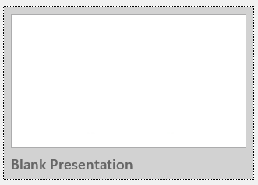
1. Launch Powerpoint and select Blank Presentation.

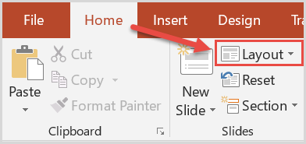
2. From the Home tab, select Layout then Blank.

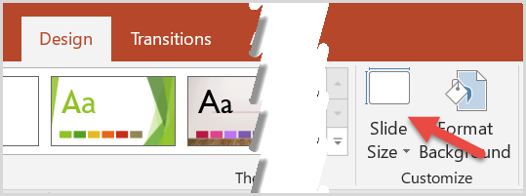
3. Click the Design tab, then click Slide Size (to the right) and select Custom Slide Size.

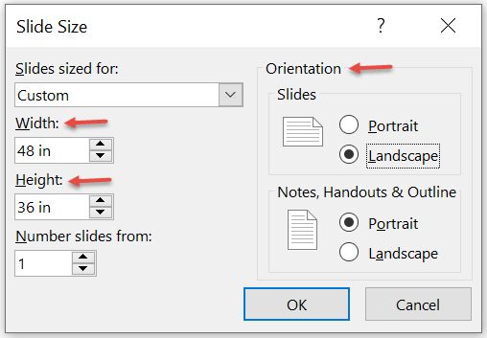
4. Set slide dimensions and orientation.

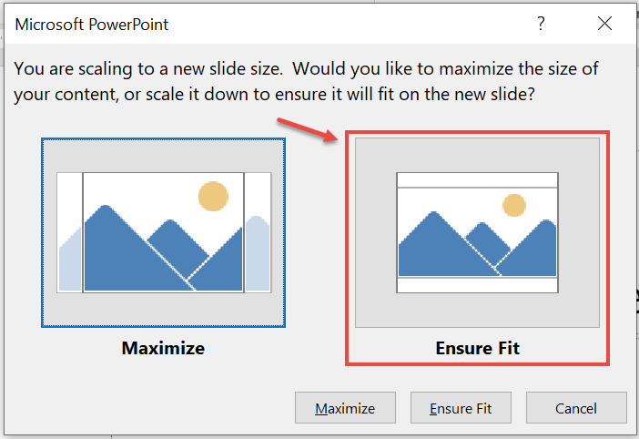
5. Select Ensure Fit.

Visual Guide: Organizing the Layout
Images are from Office 2019

Add boxes to organize information.
Insert Shapes to arrange the information on your poster, then insert Text Boxes to add text. You can also copy/paste from other sources. Remember to keep your font uniform.
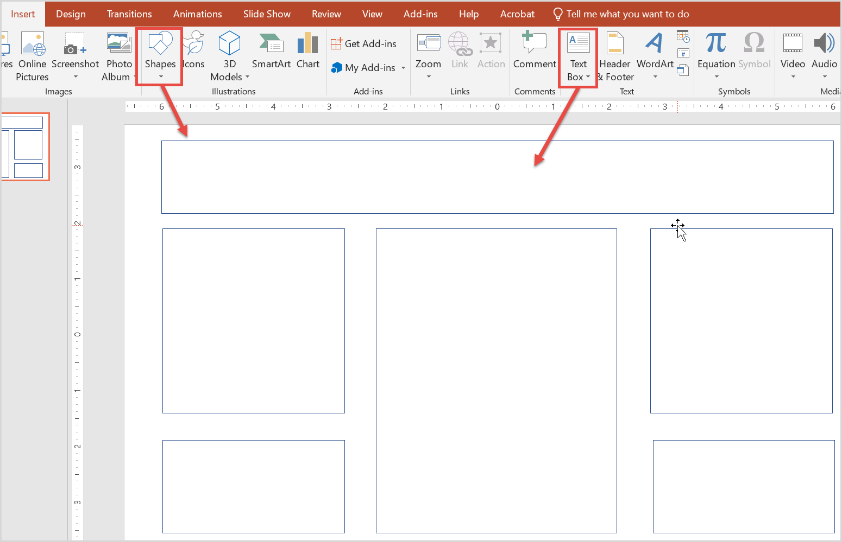

Group elements to easily move content.
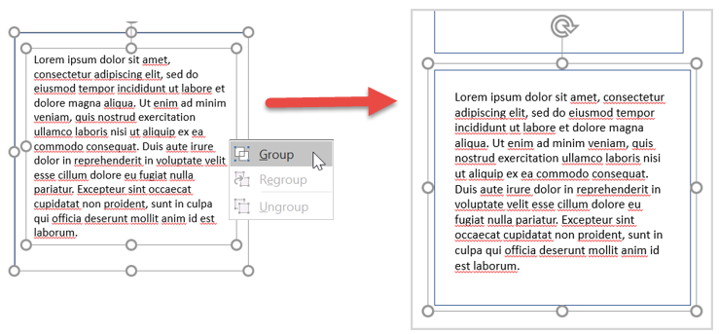
Select multiple objects, such as a text box and the shape you have added it to, by holding down the control key and clicking on the edge of the objects. Once selected, right click (along the edge of an object) and select Group. This will create one object that can be easily manipulated.

