VPN: Install and Connect
VPN will allow Clark community members to securely access Clark University network resources as if they were on the campus.
If you have any questions or issues, please contact the Help Desk at helpdesk@clarku.edu or 508 793 7745.

Install
If you are using an older version of Clark’s VPN, please disconnect prior to following these instructions.
- Visit https://vpn.clarku.edu
- If prompted, log in with your Clark email address, and your usual password. You may be asked to authenticate using multi-factor authentication (MFA)
- Choose the correct installer for your device.
  - Most Windows users will need “Windows 64 bit GlobalProtect Agent
  - If you’re unsure on which is appropriate for you, click here to learn more.
- Open the downloaded file.
  - Most users will find this in their Downloads folder. The file is usually called GlobalProtect64.msi
- Follow the onscreen prompts, clicking Next to use the default settings
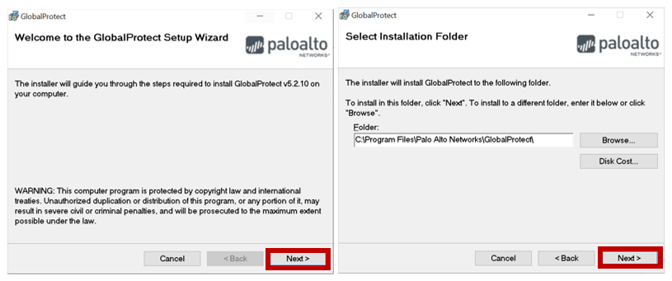
- If asked “Do you want to allow this app to make changes to your device?”, choose “Yes”.
  - Note that the application name maybe different to the screenshot below.
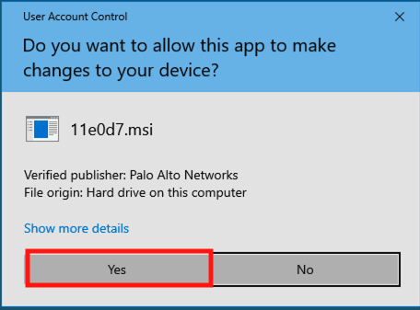
- After a short time, the installation will complete.

Connect
- Open GlobalProtect from your system tray by clicking on the ˄ icon in the bottom right of your screen, and clicking on the Global Protect icon (a grey globe)
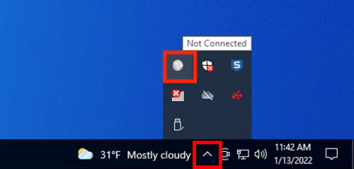

  - Alternatively, click on the Start Menu and locate and click on GlobalProtect. GlobalProtect may be in the Palo Alto Networks folder
- Enter vpn.clarku.edu as the portal address
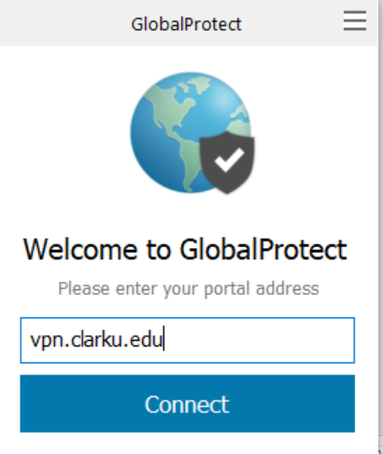
- Enter your Clark username and password and click Sign In
  - Use just your username, and not your full email address (for example use JClark and not JClark@clarku.edu
  - If you are already logged in, you may not see this screen.
- Your web browser may open asking for you to log in again to your Clark University account (using your Clark email and password).
  - If you are already logged in, you may not see this screen.
- A new window will display Clark University’s VPN Policy and a disclaimer. Close this window after reading the policy.
- You are now connected to the Clark University VPN.
  - You can monitor your connection by opening the system tray. When connected, the GlobalProtect icon will have a check mark, as seen below

