Fix Sophos After Mac OS Self-Upgrade on Your Clark Mac

Clark University
Updated October 2023
Information Technology Services
Helpdesk@clarku.edu

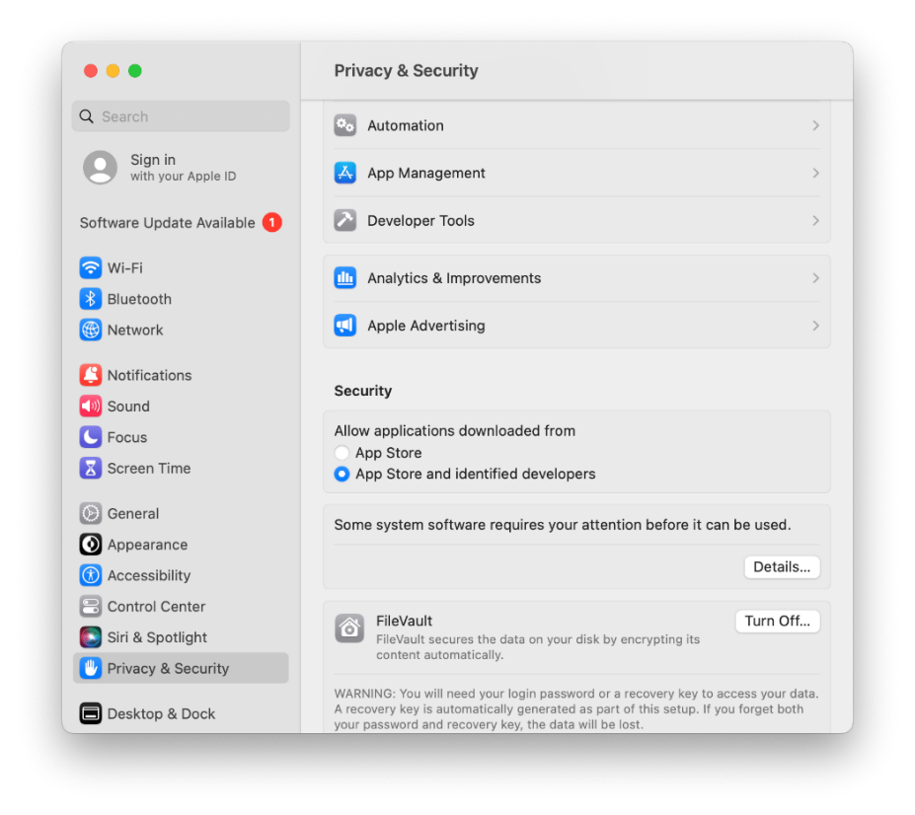
- Click on the Apple icon in the upper left corner of your screen. Select System Preferences. Click Privacy & Security from the left column.
- In the security section, underneath text reading “Some system software requires your attention before it can be used,” click on Details.

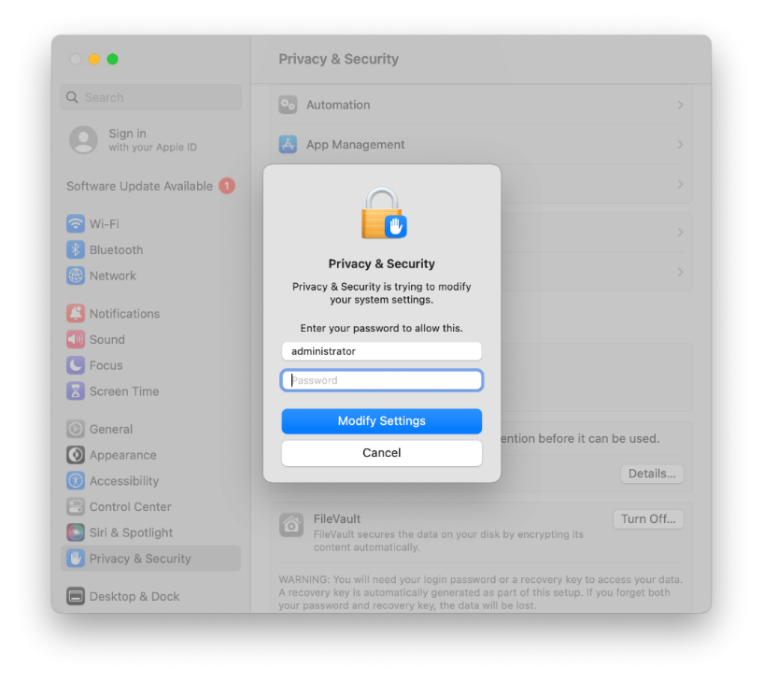
- In the pop-up window, enter your Mac password and then click Modify Settings.
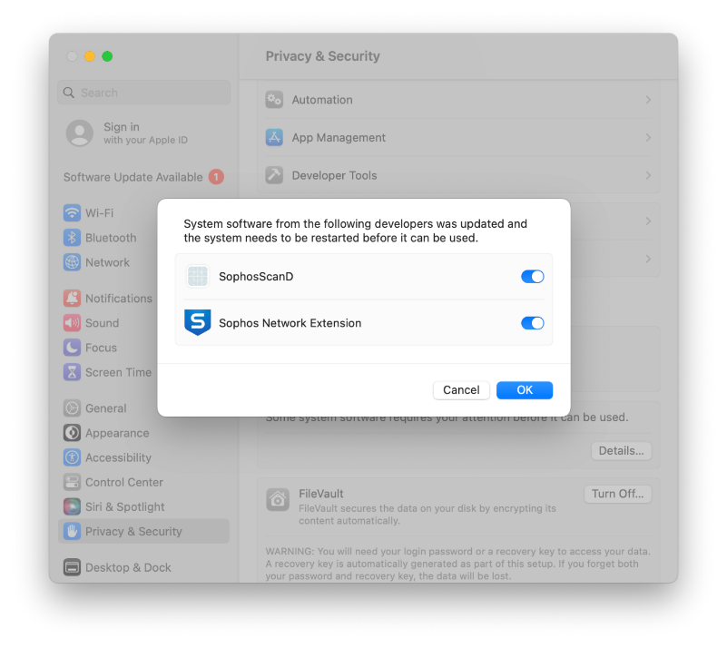
- In the next pop-up window, toggle both buttons to turn them blue and activate them. Then click OK.

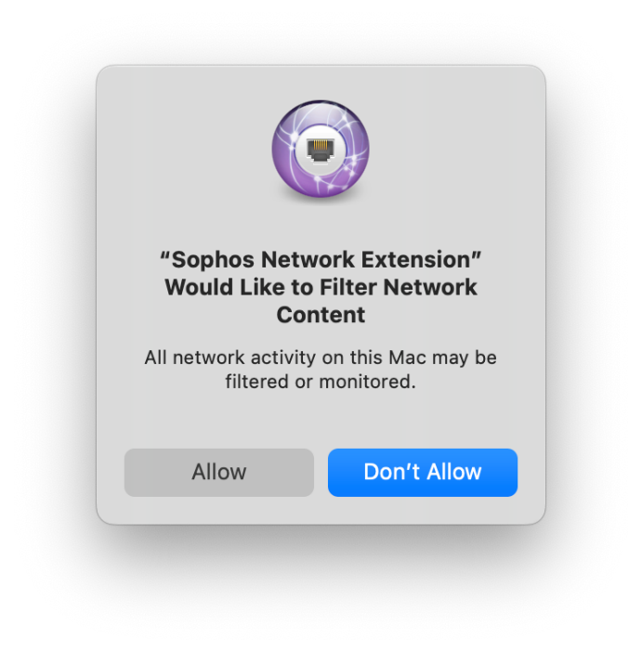
- When you see a “Sophos Network Extension” message, click Allow. Leave the System Preferences window open.
- In the upper right of your screen, locate the Sophos icon in the menu bar. Click the icon to open it.
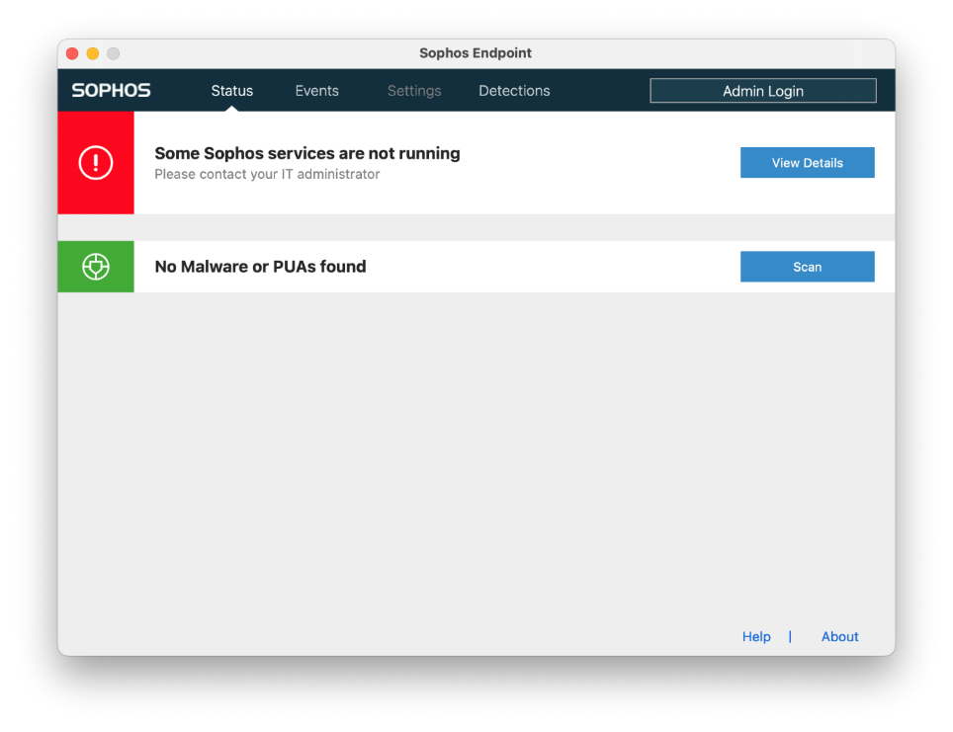
- In Sophos window, click About.

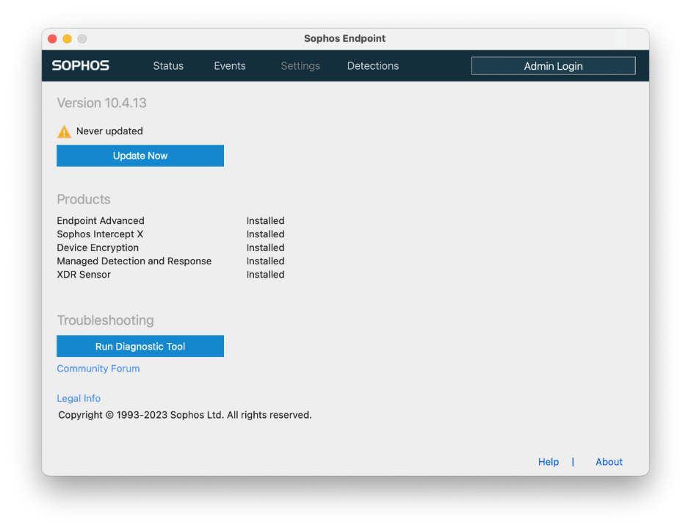
- Click on Run Diagnostic Tool.
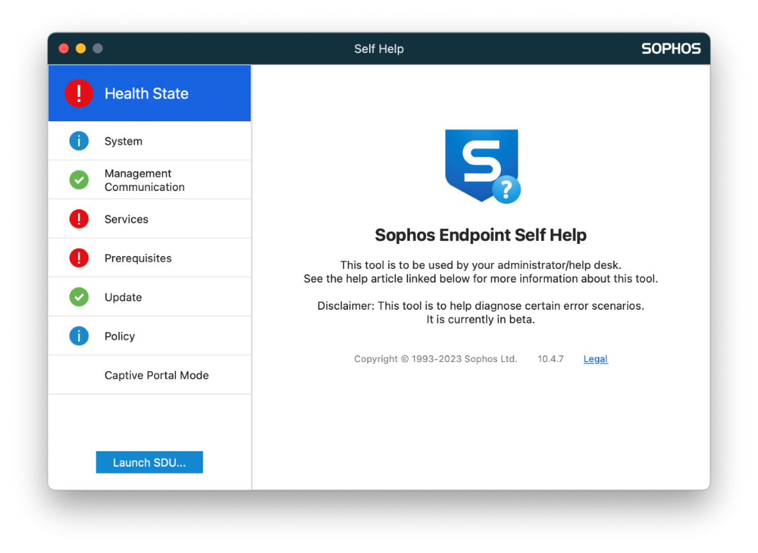
- In the Self Help window, click Prerequisites in the left column.

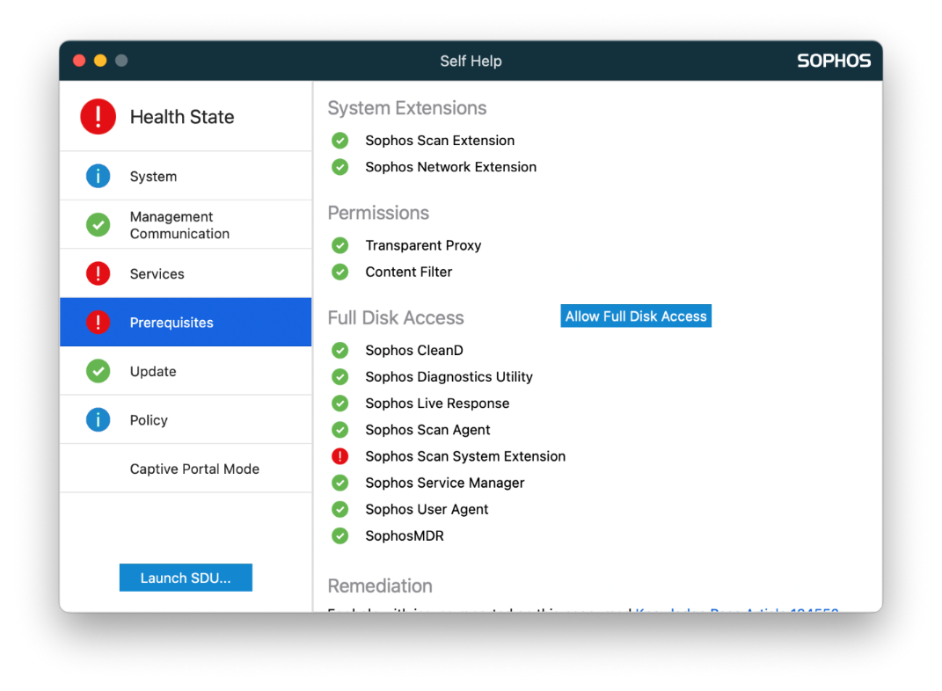
- Click Allow Full Disk Access. Leave the Self Help window open.
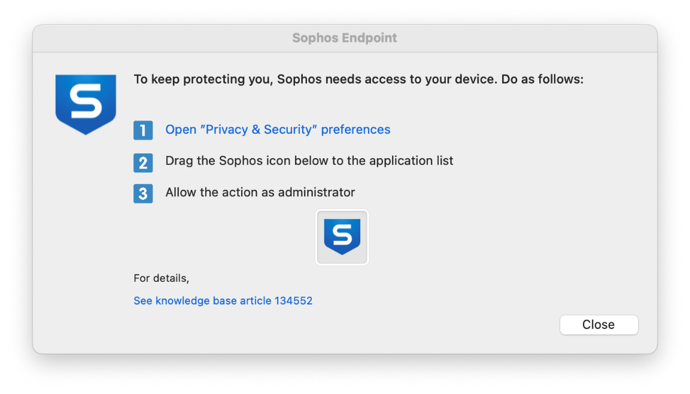
- A small Sophos Endpoint window with two icons will open. Move this new window to the side of your screen for a moment.
- At this time, you should have three windows open on your screen: System Preferences, Sophos Self Help, and Sophos Endpoint. Place the Sophos Self Help window and the System Preferences window side-by-side on your screen.

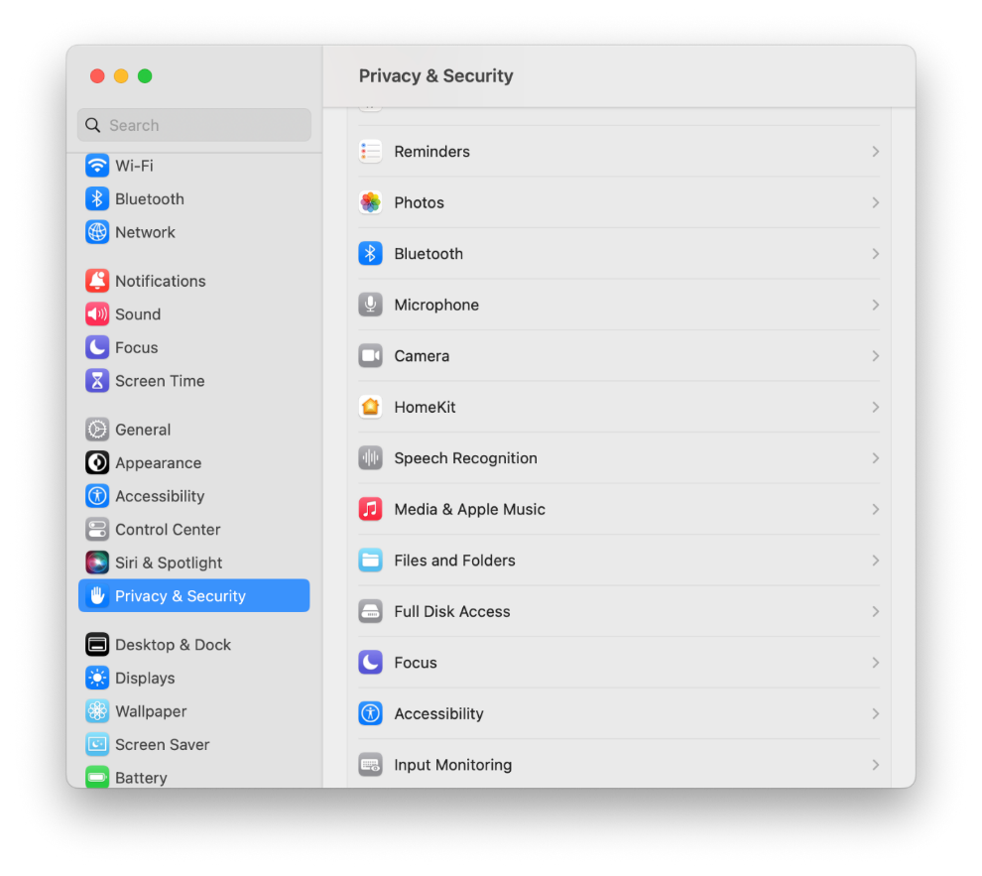
- In the System Preferences window, click Privacy & Security and then click Full Disk Access.
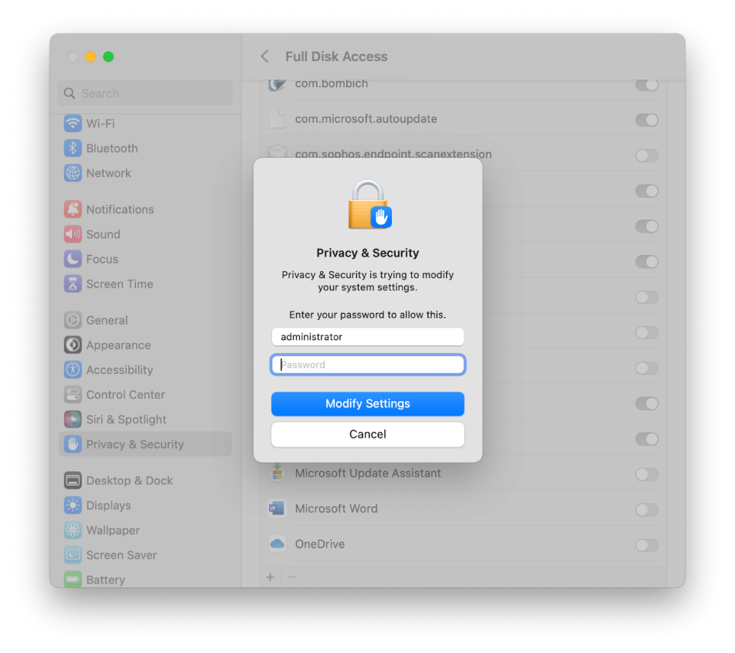
- Enter your Mac password and click Modify Settings.
- In the Sophos Endpoint window, click and drag the S icon into the Full Disk Access section of the Systems Preferences window.
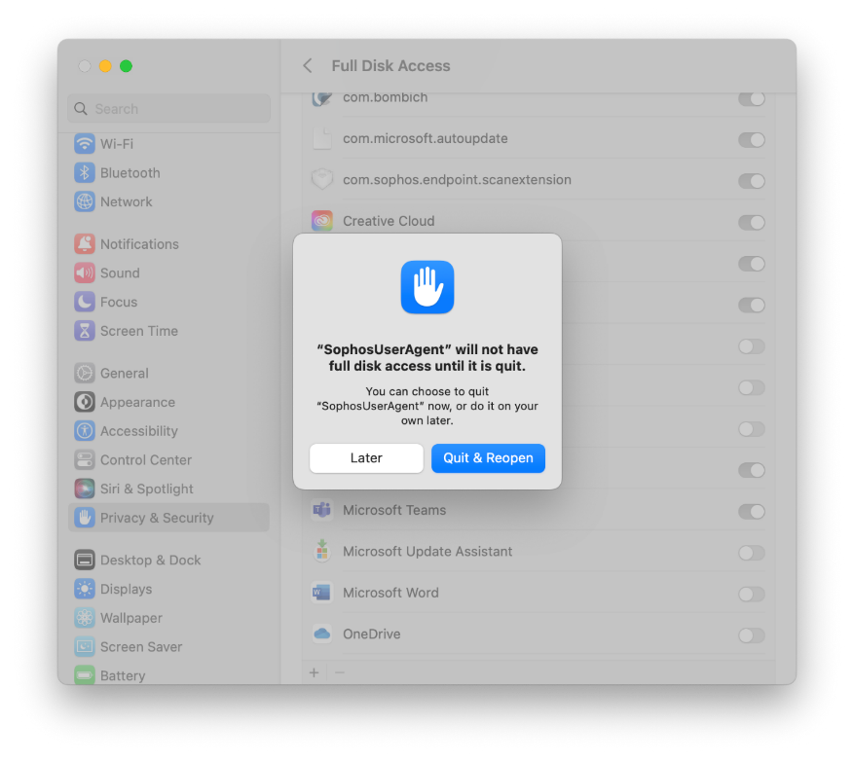
- After dragging the icon, you’ll get a message regarding “SophosUserAgent.” Click Quit & Reopen.
v

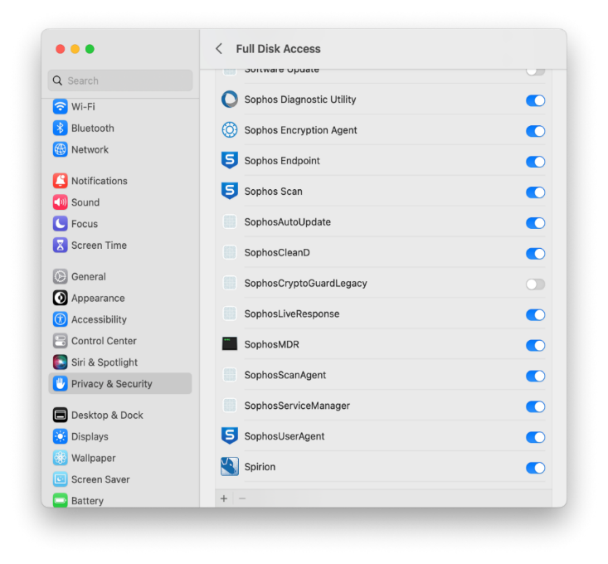
- Next, in the Full Disk Access window, toggle all Sophos buttons to activate them. You do not need to click SophosCryptoGuardLegacy if it is in the list.

- In the Sophos Self Help window, confirm everything in the Prerequisite section has a green check mark. If so, you are all set! If not, please send a screenshot to helpdesk@clarku.edu.
