Change Password on University Apple Computer: How-To Guide

Clark University
Updated April 2023
Information Technology Services
Helpdesk@clarku.edu

Since ITS-supported Apple computers are now encrypted and authenticated with your Clark credentials, it is essential that when you are requested/required to change your university password, you do so on your Mac device to make sure it changes on both the computer and within the Clark system.
Determine MacOS
- In the upper right corner of the screen, check for either a FileWave icon.
  - FileWave icon:

  - Kandji icon:

- If you see a FileWave icon, your device is operating on MacOS Catalina.
- If you see a Kandji icon, your device is operating on MacOS Monterey.

Table of Contents
MacOS Catalina – Reset Password on Campus
MacOS Catalina – Reset Password when Remote
MacOS Monterey - Reset Password on Campus

MacOS Catalina – Reset Password on Campus
- Make sure your Apple computer is connected to the university network (either with a wired connection or through Wi-Fi).
- Click the apple icon in the upper left corner of the screen and select System Preferences.
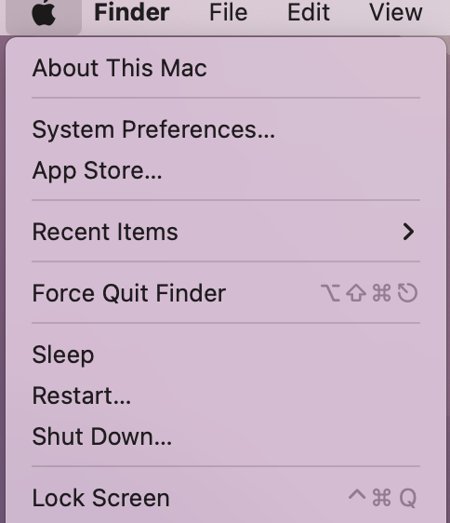
- Click on the Users & Groups icon.
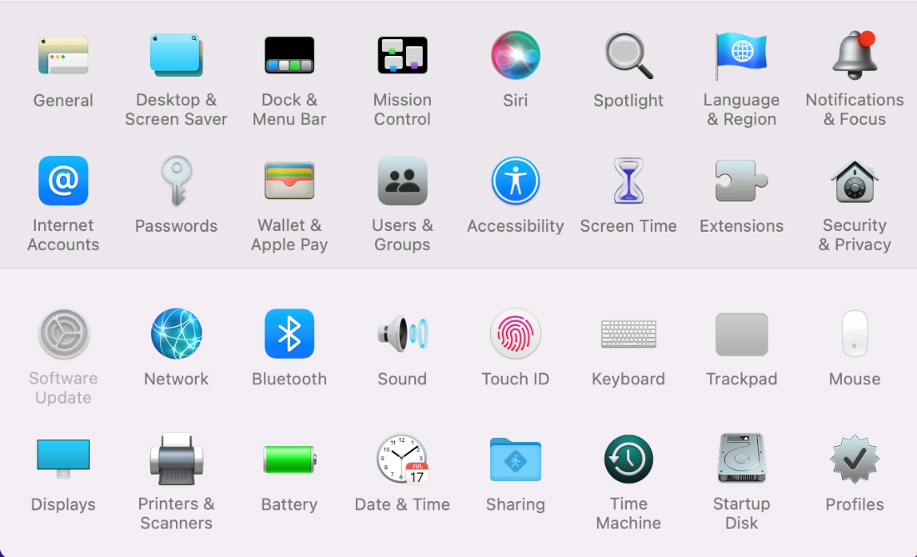

- Click the Change Password button.
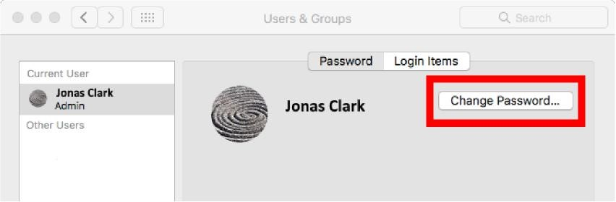
- Enter your current password and your new password (twice, to verify that you typed it correctly).
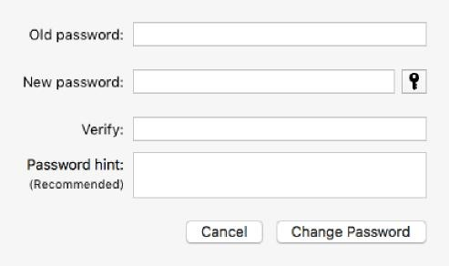
- Click the Change Password button to make the change.
- Restart the computer. Once the Apple device turns on again, log in with your new password.

MacOS Catalina – Reset Password when Remote
- Log into the Apple computer using the “old” password (the one being changed).
- Connect to Clark’s VPN.
  - Click here for directions on connecting to the VPN.
  - Confirm the computer is connected to the VPN by clicking here to make sure the Clark logo appears red and white.
- Click the apple icon in the upper left corner of the screen and select System Preferences.

- Click on the Users & Groups icon.
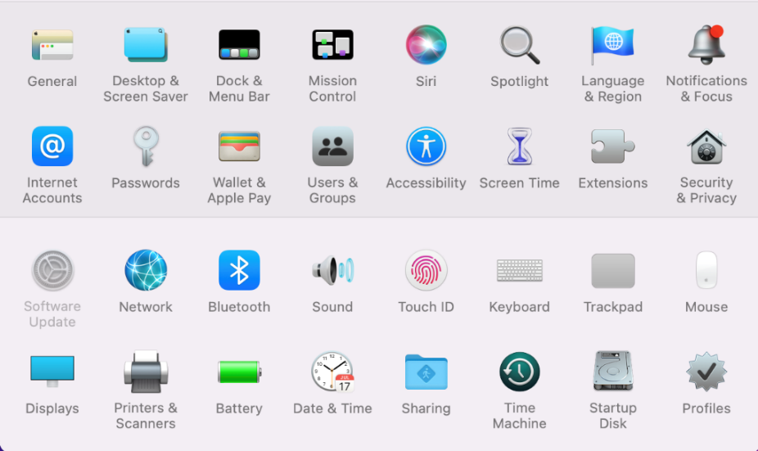

- Click the Change Password button.

- Enter your current password and your new password (twice, to verify that you typed it correctly).
- Click the Change Password button to make the change.
- Click the apple icon in the upper left corner of the screen and select Lock Screen.

- Sign back into the computer using the new password.
MacOS Monterey – Reset Password on Campus
- Make sure your Apple computer is connected to the university network (either with a wired connection or through Wi-Fi).
- In your internet browser, go to https://clarku.edu/password
  - Click the red Change Your Password button
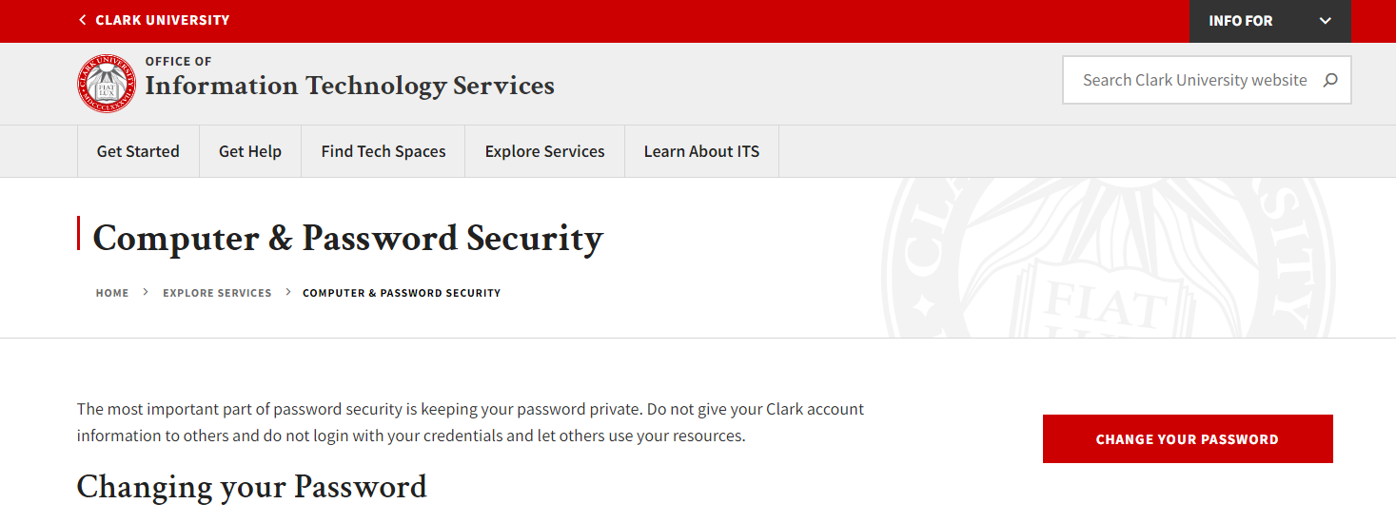
- Enter your Clark username and initial password—the password you’ll be changing.
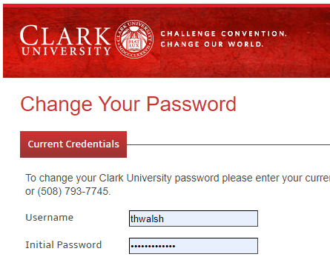

- Enter your new password twice. Next, review Clark’s Appropriate Use Policy and click the checkbox before clicking Submit.
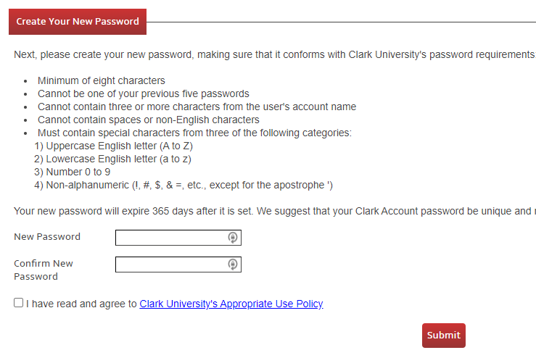
- Close the internet browser. In the upper right corner, look for Kandji’s butterfly icon and click on it.
- Wait for approximately 5 minutes for our systems to recognize your new password.
- Once the Kandji password window appears, type in your new password and click OK.
- Restart your computer.
- When the computer turns on again, log in with your Clark username and your new password.
- You will be prompted to enter credentials for Clark WiFi. Enter your Clark username and new password. Make sure Remember this information is checked, then click OK.
- From the top toolbar, click Go and select Connect to Server.
- Select one of your file shares and click Connect.
- When prompted, enter your Clark username and new password, then click Connect. After connecting to one file share, you will be able to open any others as you normally do.
- Open a test document and print it.
- In the Printer Queue window, click the restart button.
- Enter your Clark username and new password. Check Remember this password in my keychain box, then click OK.
- Make sure your test page has printed properly.
- Launch Microsoft apps such as Teams, Outlook, and OneDrive. Please note you will need to re-enter your login credentials with your new password.
If you have any questions, or require further assistance, please contact the ITS Help Desk at 508-793-7745 or helpdesk@clarku.edu.

