Adding Authenticator as Default Factor

Updated Winter 2024
Information Technology Services
helpdesk@clarku.edu

What is multi-factor authentication?
To learn more about MFA, please click here to view a short video.
Why make Microsoft Authenticator my default factor?
All major information security organizations recommend using a modern authentication app (such as Microsoft Authenticator) for MFA, instead of SMS, calls, or secondary emails. Authenticator apps are more secure from SIM cloning, interception and social behavior phishing. Additionally, they allow users more flexibility when travelling away from their primary phone number and when offline.
Therefore, ITS strongly recommends using Microsoft Authenticator.
What do I need?
These instructions are for users who already have MFA set up with SMS, to switch to using Authenticator as your primary MFA factor.
If you are setting up MFA for the first time, please visit this page for better instructions:
To add Microsoft Authenticator as your primary MFA factor, you’ll need:
- Your smartphone with access to your SMS
- Internet access

Set-Up Microsoft Authenticator App
- Download the Microsoft Authenticator app to your smartphone using either the Play Store (for Android devices) or the App Store (for iOS devices).
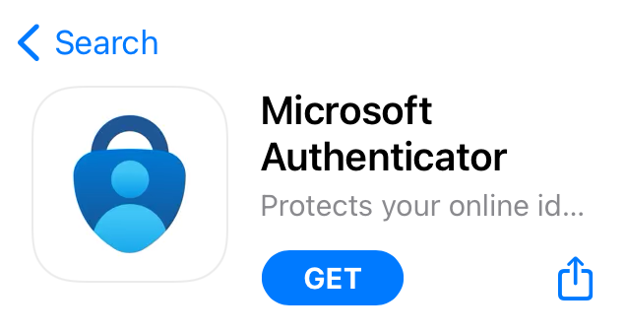
Check that the app you download was published by Microsoft corporation.
- Once the Authenticator app is downloaded to your smartphone, tap the app to open it.
- The app will ask to send you notifications: these notifications will help you authenticate your account moving forward. Tap Allow.
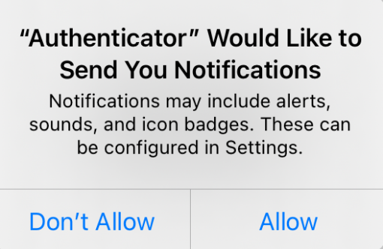
- If necessary, click the Plus icon to add a new account.
- Tap Add work or school account, then tap Sign in.
- Log in using your Clark University email address and password.
- Follow the prompts to authenticate as usual with SMS
- The Authenticator App is now set up.

Set Authenticator as your Default Factor
      - Navigate to https://mysignins.microsoft.com/security-info
      - Log in with your Clark account information, authenticating with SMS as usual if prompted.
      - Click “Change” for the Sign-in method when most advisable is unavailable.
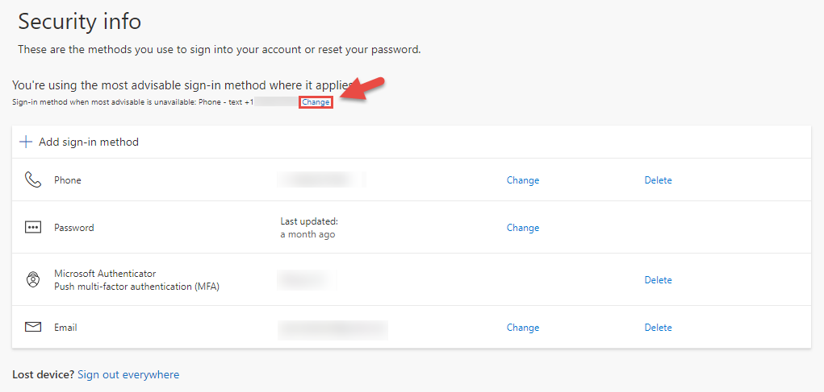

      - Choose App based authentication – notification
      - Click Confirm

